**Introduction**

This project aims to use various tools in order to perform end-to-end data science workflow processes. The inspiration behind this project was to utilize the tools and skills self-learned by the author, and also for the purpose of understanding the tools and skills used in depth. The dataset used revolves around Blinkit sale dataset that consists of multiple .csv files. The dataset used in this project can be obtained from https://www.kaggle.com/datasets/akxiit/blinkit-sales-dataset.

**Raw Dataset**

The first step in this project is to take a glance at each .csv file. This step is important to identify the values stored in each column, as well as to determine which columns are useful for analysis, and as learning features. This step is also crucial for the author to understand the dataset better. This dataset comprises of a total of 9 data tables / .csv files.

blinkit_customer_feedback.csv

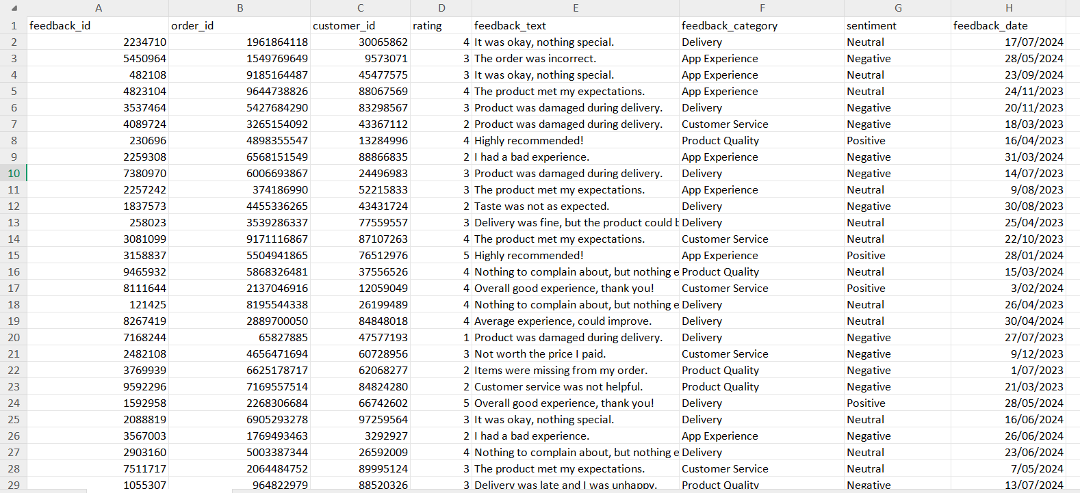

Initially, this data table can be seen to use feedback_id as its index have relation with two other tables, via order_id and customer_id. Next, the rating with sentiment columns at a first glance can be seen as columns that correlate to each other, whereby a “positive” sentiment reflects to a higher numerical rating, which a “neutral” and “negative” sentiment reflects to a lower numerical rating respectively. There is also a feedback_text column which can be viewed as a feature to determine to sentiment result. As per shown in the table in row 2, where the text “It was okay, nothing special.” results in “neutral” sentiment, and in row 3, “The order was incorrect.” is given a “negative” sentiment and row 8, “Highly recommended!” is given “positive” sentiment. The author plans to perform NLP on this data table in the machine learning section.

blinkit_customers.csv

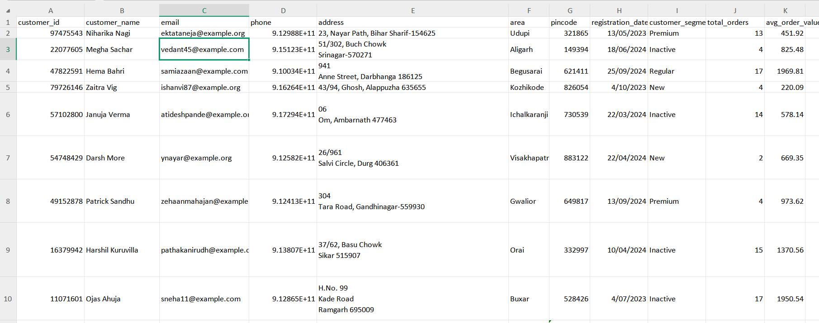

In this customer data table, there is unique customer_id for each customer, as well as customer_name, email, phone etc. There are few features which can be used as features for EDA analysis, namely the customer_segment, total_orders and avg_order_value. The order value refers to the total amount in one purchase. This means that for example, in row 2, the first customer stored in this table have an average of 451.92 in each purchase across a total of 13 purchases made. The customer_segment also does not seem to correlate to any of the other columns in this table.

At a first glance, it can be seen that the phone and address columns store values in a non-ideal manner for viewing and processing purposes.

blinkit_delivery_performance.csv

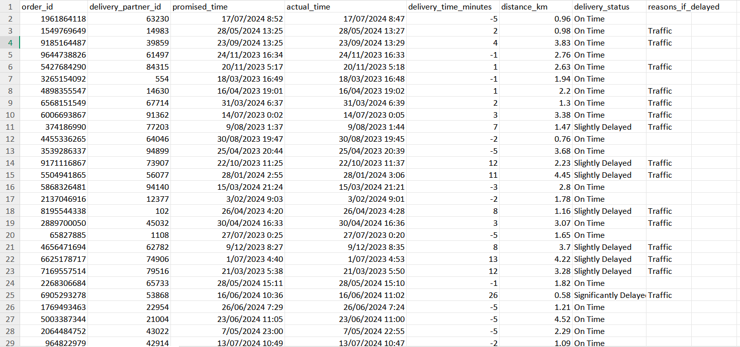

In this data table, there is a unique key in order_id, whereby each order is tied to one delivery process, instead of having a separate delivery_id for order. This either means that each order_id only have one delivery. However, due to unknown issues such as weather / road conditions, or sudden cancellations may result in delivery cancellations. This might lead to the same order_id, having to undergo another delivery.

It is also visible that both the date and time are stored in the same column. The delivery_time_minutes column reflects to the difference between the actual_time and the promised_time. There is also a direct correlation between the delivery_time_minutes column and the delivery_status column, whereby value 5 and below in delivery_time_minutes are labeled as “OnTime”, values between 6 and 15 are labeled as “Slightly Delayed” and the rest as “Significantly Delayed”.

blinkit_inventory.csv

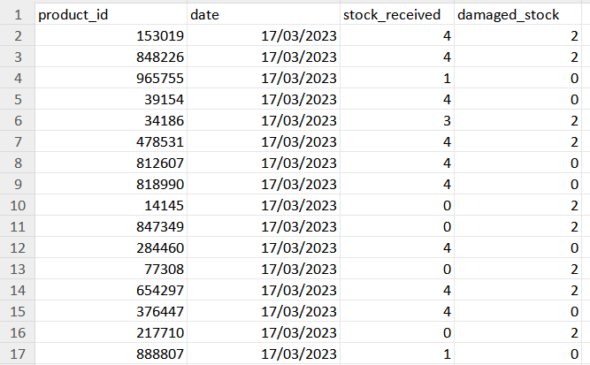

As blinkit serves as a online store and warehouse for groceries, it is vital for the business to check on damaged stocks when receiving stocks. At one glance, it can be seen that the store purchase products in bulk, as there are multiple products purchased on the same date.

blinkit_inventoryNew.csv

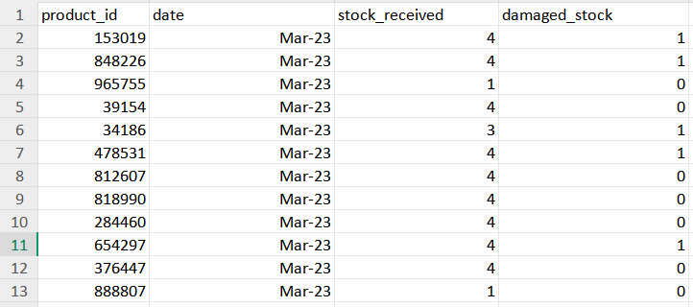

This data table is almost identical to the “blinkit_inventory.csv” table. The main difference is how the date column store its values, and also the damaged_stock values in relation to its product_id. Therefore, one of the inventory tables is actually unnecessary, and will therefore be not used in future processes. Alternatively, the two table values can also be consolidated into one inventory table through the product_id on the sum of stock_received and damaged_stock respectively.

blinkit_marketing_perfomance.csv

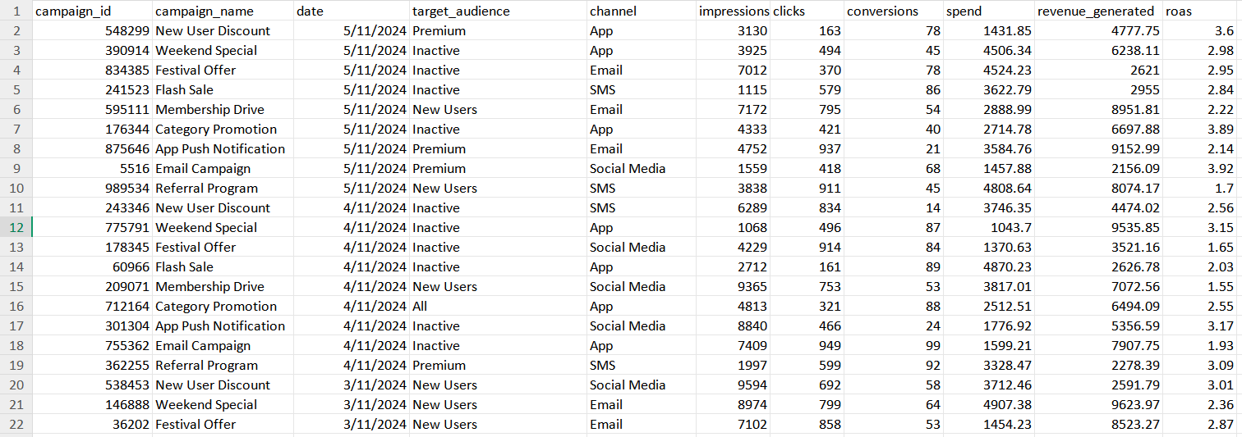

This data table shows campaigns done, and the performance of the campaigns through revenue_generated. The “roas” column reflects to the revenue generated against the cost for the campaign. The data table also shows the target audience and the channel it uses for each campaign. The user involvement in the form of impressions, clicks and conversions are also recorded. The “conversions” column here refers to when a user completes a desired action, such as making a purchase, signing up for newsletter, adding items as favourite etc.

blinkit_order_items.csv

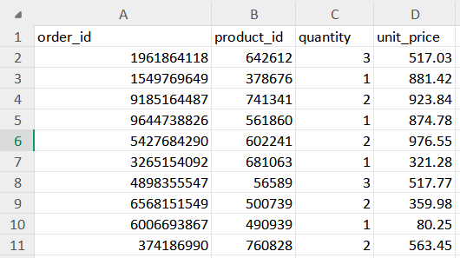

This data table displays a unique key in order_id, which distinct product_id is tied to each order_id, the quantity and unit price of product purchased. At first glance, it is important to identify if the order_id can only be linked to one product_id or multiple product_id. This is because in general, a shopping cart which generally reflects to an order, may consist of several products. When this happens, the order_id column may have duplicate values which are useful.

blinkit_orders.csv

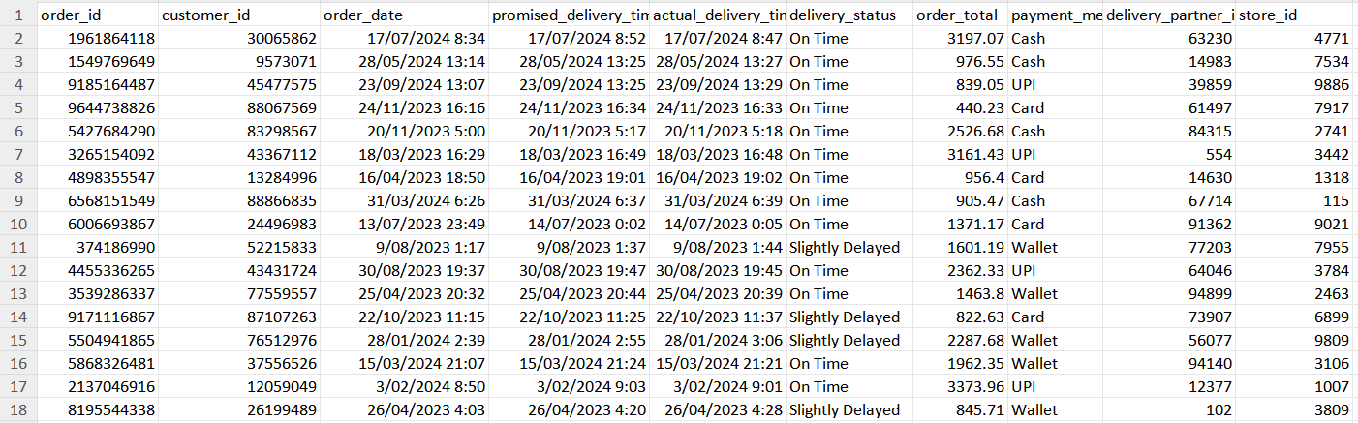

This data table shows the orders made by customers in detail, with the total amount purchased, payment method used, as well as the delivery made on the order. There are also two different unique keys here, namely, delivery_partner_id and store_id, which are not available as part of the data tables accessible to the author.

blinkit_products.csv

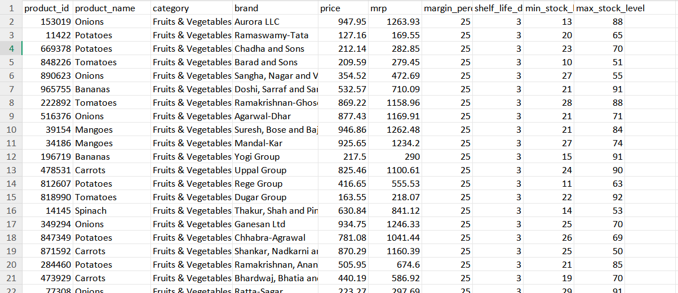

The last data table refers to the products table, where all the product data in the warehouse is stored. In this table, it is clearly visible that there are identical product name stored to different product_id due to the difference in brand. The “mrp” column here refers to the maximum price which can be sold to the customer for the respective product. In addition, there are also minimum and maximum stock levels, as well as shell life as means for stock management.

**Data Preprocessing (Microsoft Excel / WPS)**

Once the data table has been briefly identified and analyzed, the next step is to clean the data. The data cleaning process is done by utilizing the formulas and features available in Microsoft Excel/WPS.

The first step in data cleaning is to remove duplicate records in all .csv files, as they influence in an unwanted manner during the analysis stage later.

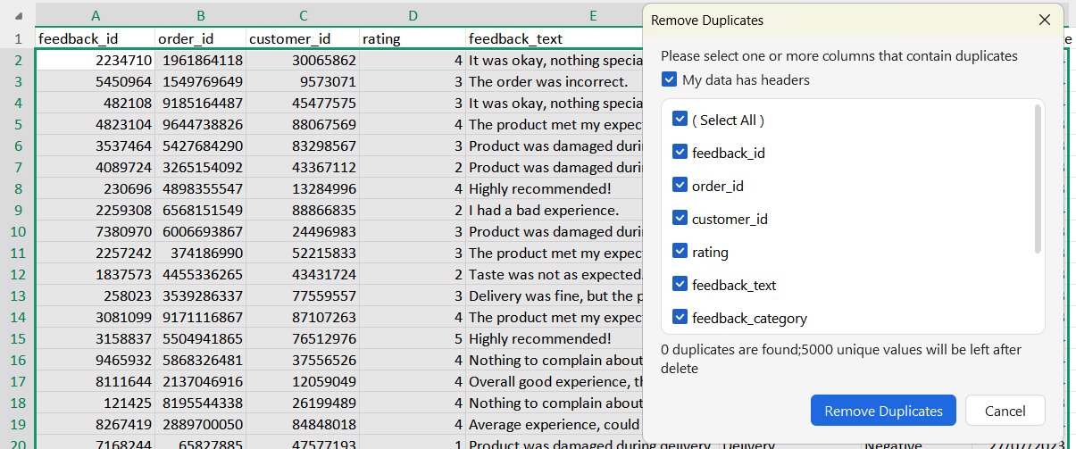

The next step is applying filters to all columns in each .csv file. This step is vital to assist us identifying a difference in terms of values stored, such as dates, time etc.

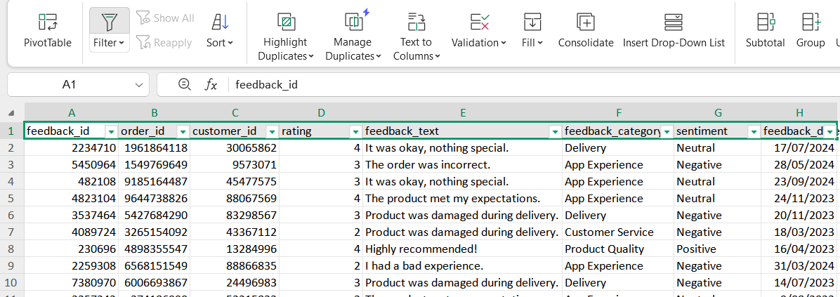

In order to ensure there are no unnecessary whitespaces in all columns in each.csv file, the TRIM() function is applied.

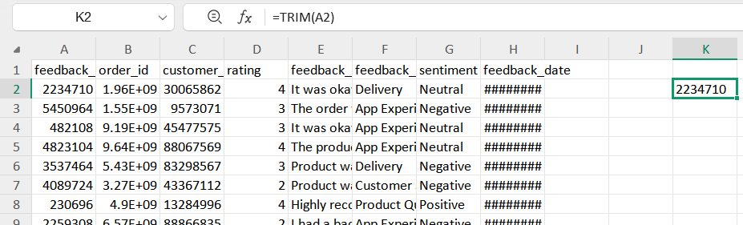

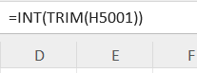

blinkit_customer_feedback.csv

In this data table, all the columns store values in a clean and easy to understand way. 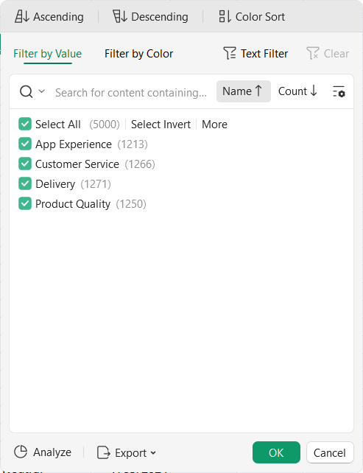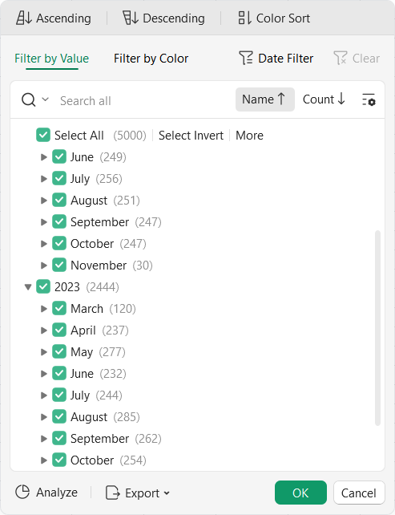

As we can see, there are no odd categories or such as “App Experience” with “App experience” or “App Experience!”. The date values are also stored uniformly and in the wanted date format. Hence, there is no complex cleaning and pre-processing required.

blinkit_customer.csv

In this data table, there are two main columns that needed to be cleaned, namely the “phone” and “address” columns. In the “address” column, the data were stored in a single line and multi-line addresses. This might cause issue in the data exploratory stage. Therefore, there is a need to unify the format for addresses stored.

For this reason, the substitute method is used.

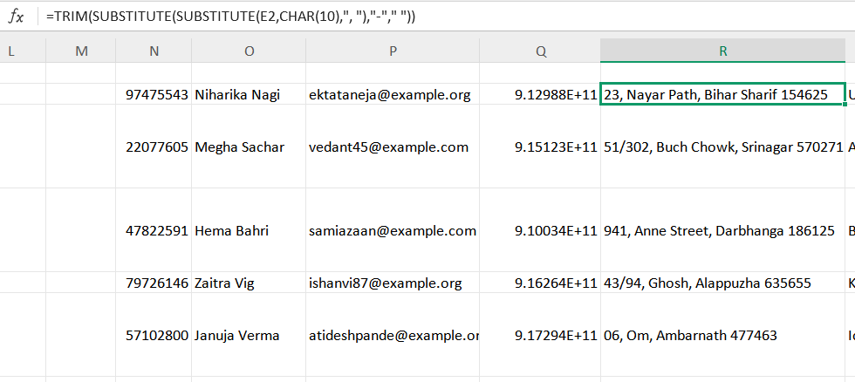

Next, almost all of the values stored also had no comma between the city and postcode. In order to differentiate between the city and postcode easily, and also for future analysis on address purposes, “TEXTBEFORE” and “TEXTAFTER” functions are used to add a comma between them.

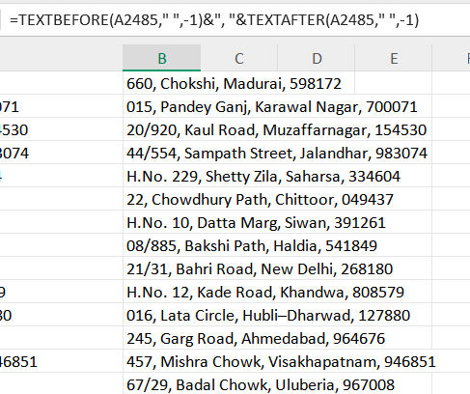

For the “phone” column, the number was formatted to have exponential, which might influence the output in analysis. Therefore, it is changed to text and 0 decimal place is applied.

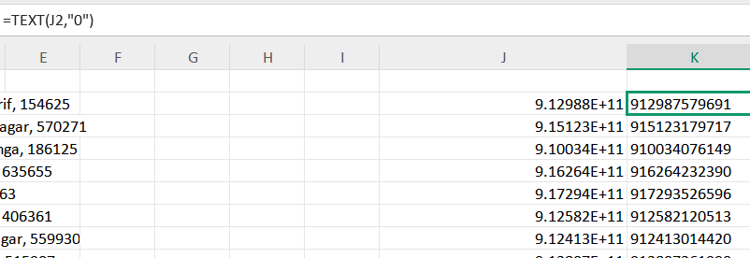

blinkit_delivery_performance.csv

In this .csv file, the only unnecessary change determined was to split date time in both promised_time and actual_time columns to date and time respectively. This step is necessary as both date and time may be beneficial variable to uncover time-series trends.

In order to get the date and time separately, INT() function and the formula of cell value minus INT() are used. Moreover, the cells need to be formatted appropriately to get the right output.

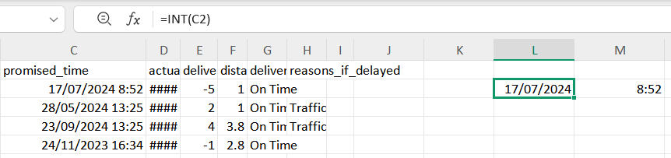

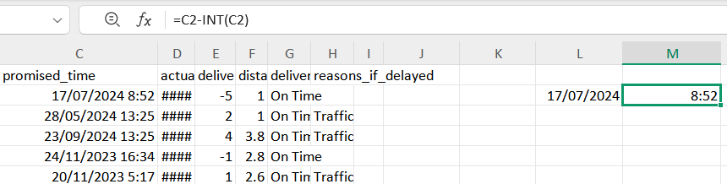

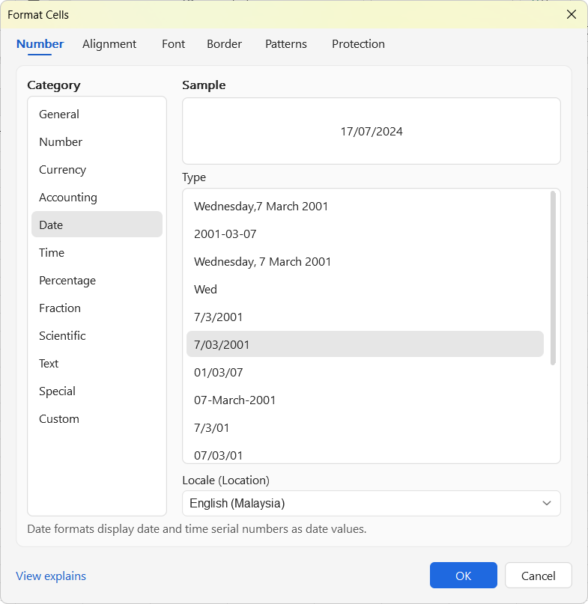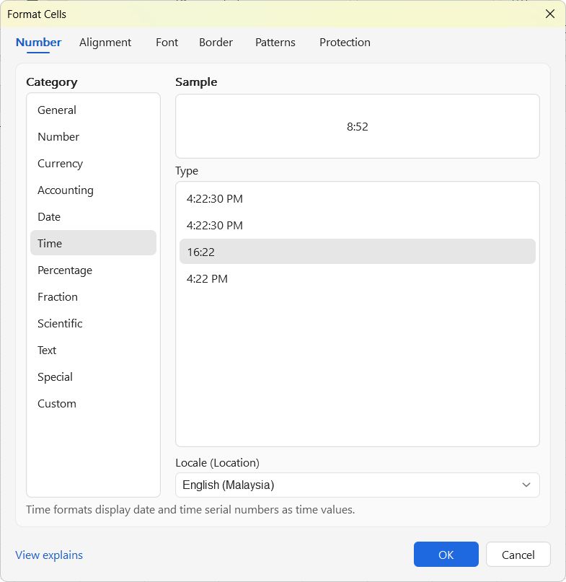

This will result in two extra columns, namely promised_date and actual_date, which stores the dates. Meanwhile, the promised_time and actual_time columns store only the time data.

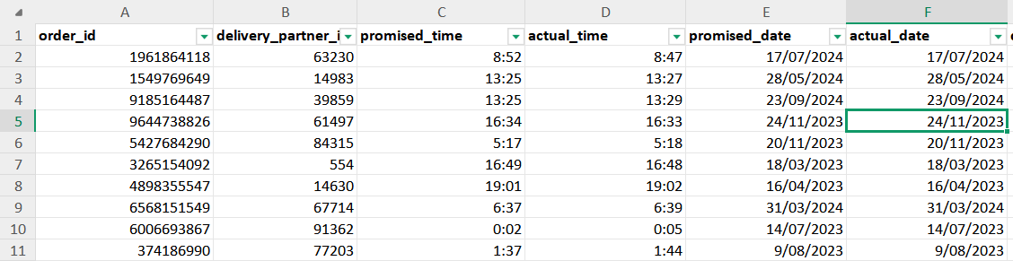

blinkit_inventory.csv

This .csv file stores data in a uniform and clean manner. Hence, there is no need for any other data cleaning steps needed.

blinkit_marketing_performance.csv

Similarly, this .csv file also had values stored in a uniform and easy to comprehend way. Therefore, no further data cleaning steps are unnecessary. The “roas” column name is changed to “return_from_ad”, as an easier way to understand that the values in this column refers to the revenue gained against the cost spent on the campaign.

blinkit_order_items.csv

This .csv file also had values recorded in a clean manner. Hence, no further data cleaning steps are necessary.

blinkit_order.csv

This .csv file has columns that store date and time in the same column. Therefore, in order for better readability and analysis purposes, the date and time are separated into separate columns. Besides that, in all the .csv files accessible, there is not any table that uses delivery_id and store_id as unique key. However, these two columns are not removed as they could be potentially relevant in other use cases.

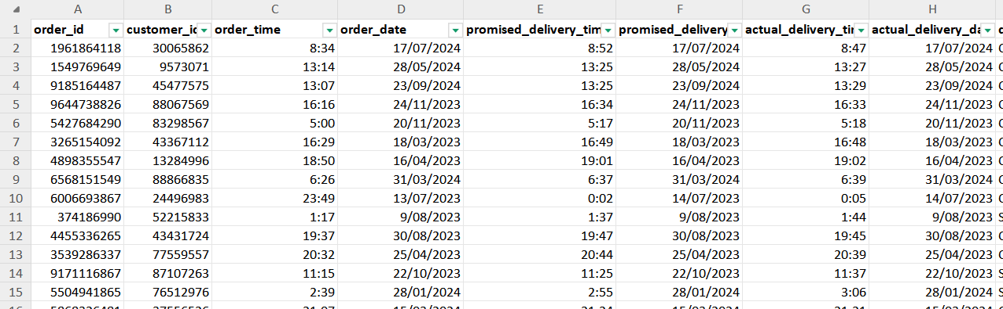

blinkit_products.csv

This .csv stores its values in a clean and easy to understand way. Therefore, the only change made was to the “mrp” column name to “max_sell_price”. This column refers to the maximum retail price set by the manufacturer, which the store can sell for that particular product.

The final step was to store all the formatted .csv files into one master data file. The necessary formatting on the columns were applied to the consolidated master data .csv file using the formulas and functions used before.

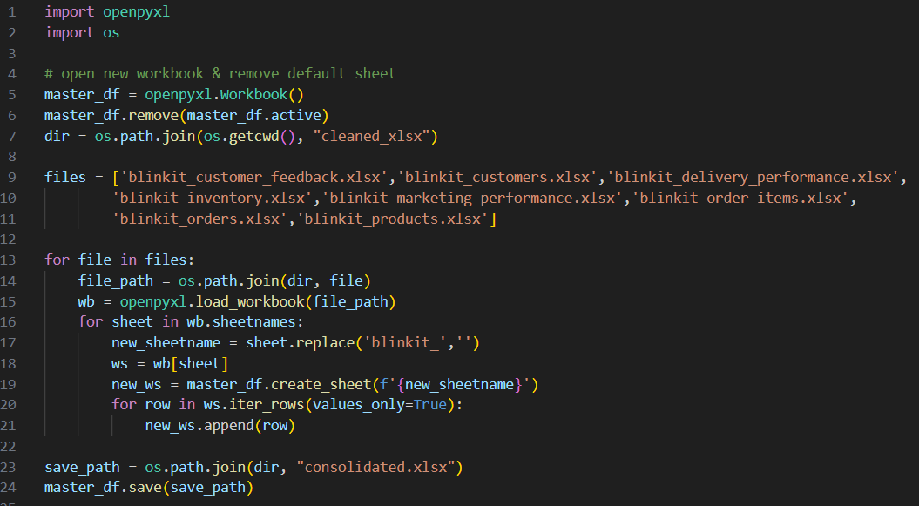

In order to import data into the table in the PostgreSQL database, the files will need to be formatted into .csv files. After the conversion to .csv files from .xlsx file format, the column formats may be reverted again. Therefore, adjustments for the columns with incorrect format are made.

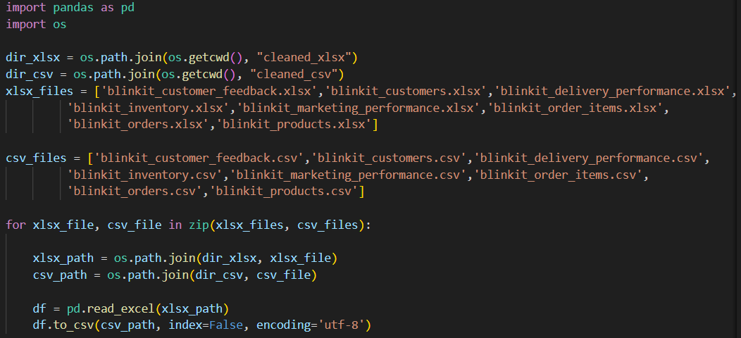

**Exploratory Data Analysis (PostgreSQL / pgAdmin4)**

This stage is performed using SQL queries with PostgreSQL on the pgAdmin4 platform. Before any analysis can be done, the table structures will need to be defined in a PostgreSQL database.

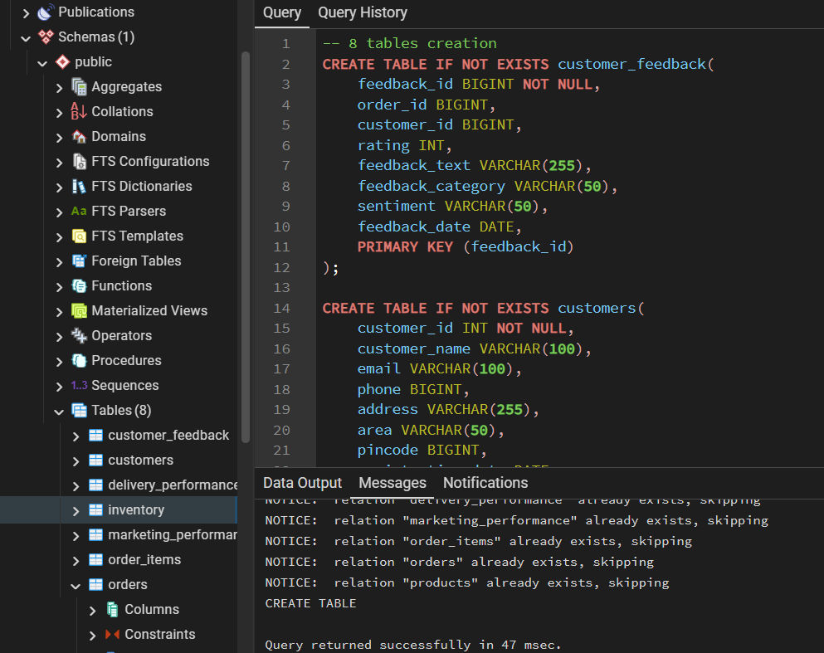

Once the table structures have been successfully defined and created into the database, the data can then be imported into the tables individually.

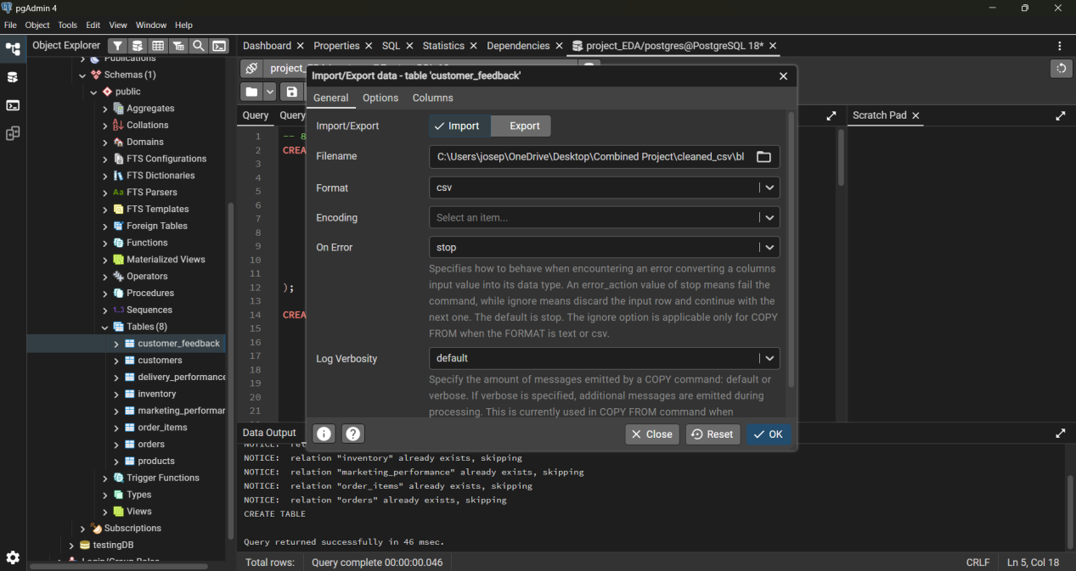

After the data for all the tables have been successfully imported, the number of rows imported are checked and modified.

Case 1 : Positive vs Negative Sentiment Distribution in Delivery Feedback by ‘Premium’ and ‘Regular’ Customers in Year 2024 and Year 2023

This case study aims to find the positive and negative feedback distribution on delivery category across year 2023 and year 2024. One of the benefits of this case study is identifying the strength and weaknesses of the existing delivery system, and as well as potentially exploring on new areas of development for deliveries. The reason behind this case study is because Blinkit store is an online store that sells groceries. This means that the stock movement between the store and consumer is required to be short and fast, but the packaging quality will need to be maintained. Therefore, delivery plays a vital role, and feedback is one of the component that is able to distinguish the delivery performance. It is also significant for a business to maintain its regular customers as this helps the business to manage stock at a more consistent level.

First, the customer_feedback table containing feedback information, and the customers table containing customers information are joined. This is because “Premium” and “Regular” customer categories are located within the customers table, whereby the feedback category and sentiments are in customer_feedback table.

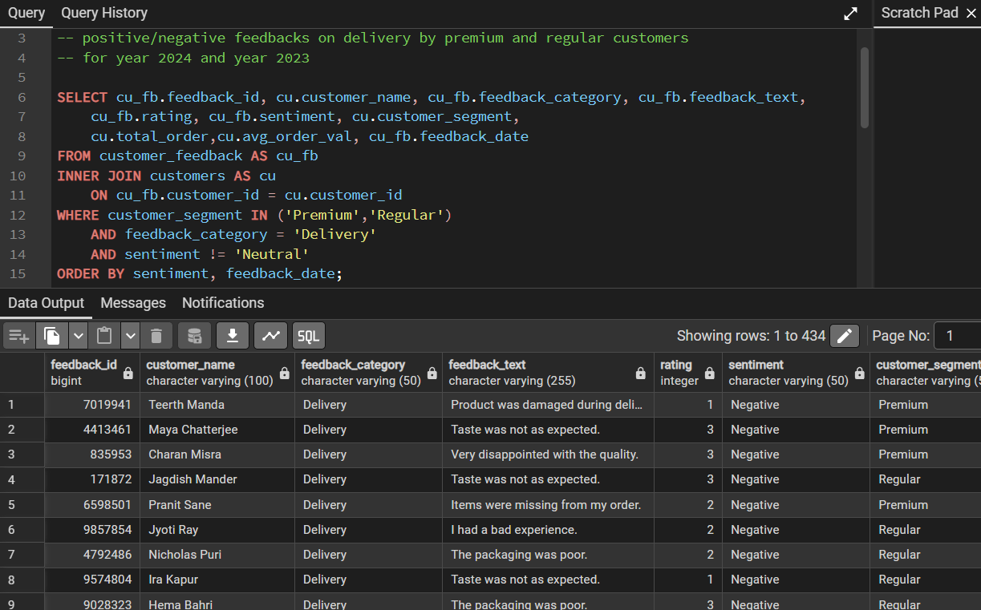

Next, we will need to find the distribution of number of feedback across year 2023 and year 2024 for Premium” and “Regular” customers. It is important to measure business performance whether it is based on monthly or annually based on certain metrics. Therefore, this case aims to find the difference between year 2023 and year 2024 in terms of the feedback by “Regular” and “Premium” customers.

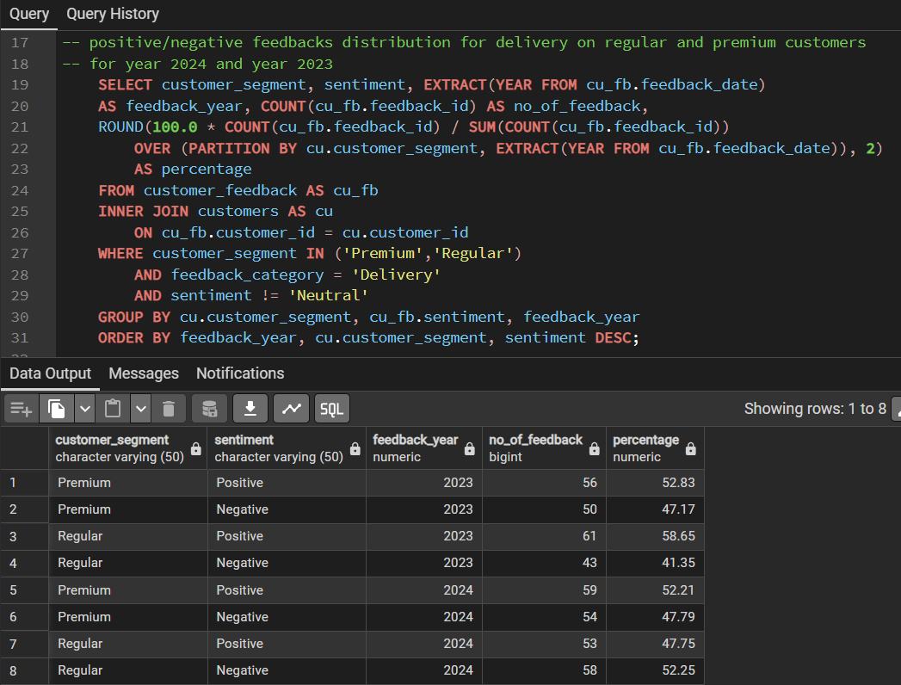

Based on the result of year 2023, the number of positive feedback for delivery is more than its negative feedback counterpart. In year 2024, the number of positive feedback for delivery has dropped. This means that in terms of delivery category, the regular customers for Blinkit store are generally unsatisfied with the service provided. The percentage drop for “Premium” customers is not much, however, this also depends on the number of “Premium” customers in Blinkit store. The significant drop can be found in the “Regular” segment, where in year 2023 the percentage of positive feedback was 58%, whereas in year 2024, the positive feedback has dropped to 47%.

The same method can be used to find out different feedback category for positive and negative sentiments for “Regular” and “Premium” customers.

Case 2 : Top 5 Type of Products & Product Category with Most Number of Negative and Positive Feedback by “Regular”,”New” and “Premium” Customers

The rational behind this case study is to identify which products have the most customer engagement. It is important for a store to identify the products which are trending in market and also popular in their store, as these products generate the bigger portion of the revenue for the store. In addition, this also helps the store uncover which type of products have a high attraction rate, and as well as determining why certain products are performing well, whereas some are not. This query utilizes 4 tables which are the customers table to get the customer category of “New”, “Regular” and “Premium”, customer_feedback table which uses the number of feedback for each product, the product table to get the product name matching to the product_id in the order. Lastly, the table order_items which has the order_id to link between products table and the customer_feedback table as both of these tables have order_id as an identifier.

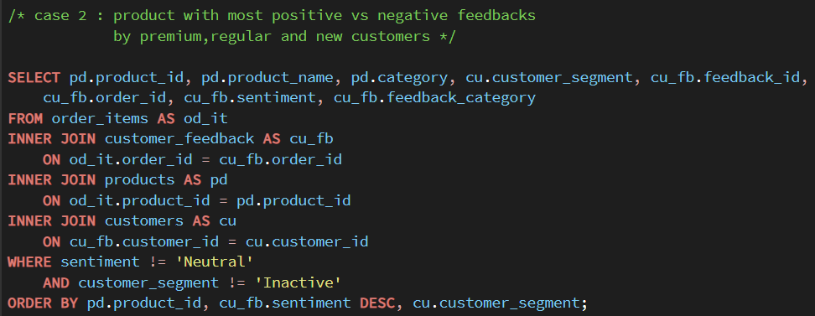

In order to get the top 5 products with the most number of negative and positive feedback, the ROW_NUMBER() function is used as an indicator for rank by assigning numbers that are sorted based on the number of feedback in descending order.

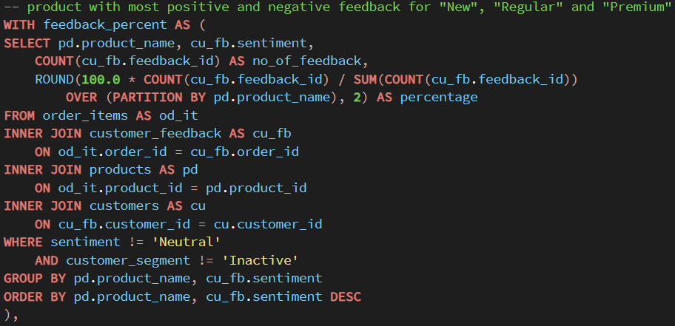

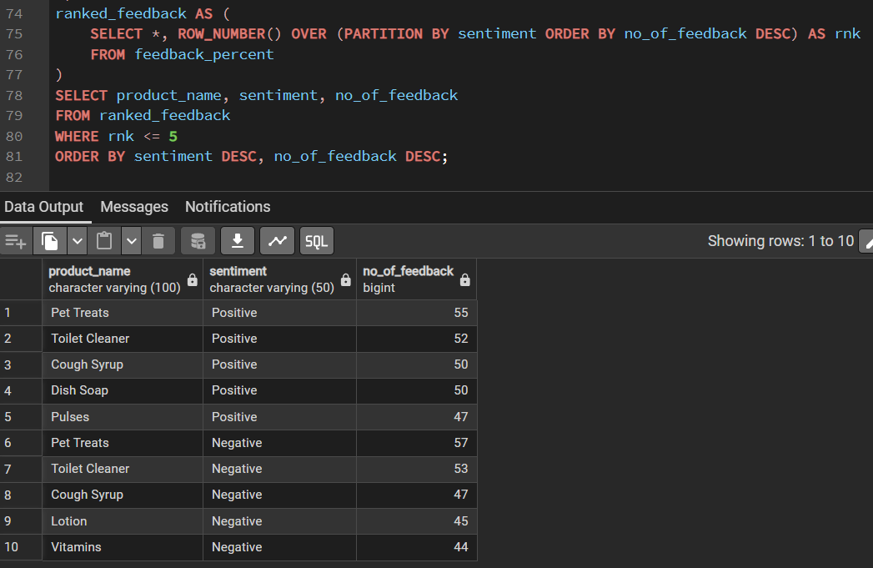

In the same way, the top 5 product categories with most number of negative and positive feedback can be found.

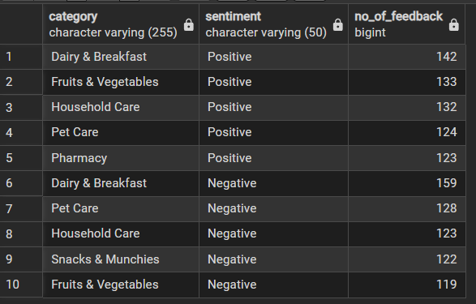

Based on the result shown, there are a lot of customer engagement on dairy and breakfast products. This could suggest that a large percentage of the customers are working adults or single household who wants to reduce time going out for groceries, and have them delivered instead, or would rather cook at home to save food cost eating outside. It could also be easier for people to look up for products online than in physical stores for these products.

On the contrary, this could also suggest that dairy & breakfast products by different brands have different standards of packaging, and therefore, resulting in relatively significant number of feedback in both positive and negative sentiments. Besides that, it could also suggest that the stock in category such as “Dairy & Breakfast” and “Pet Care” products are not managed and maintained at a consistent level, or the shell lifespan for those products need to be revised.

Case 3 : Top 5 Areas with Highest Average Order Value and Top 5 Areas with Highest Number of Orders, and the Delivery Performance in those Areas

This case study focuses on finding areas where orders are made and delivered to, and how the delivery performance are in those areas. It is important for the store to figure out if the area with most generated revenue and delivery count has a reputable delivery performance, as it aids in customer retention. Areas with high revenue but poor delivery performance can be looked at, and the business can discover better delivery partners that are closer to those areas, or delivery partners that prioritizes and operate in those areas as well. Moreover, the business can also take the result as an opportunity to study the market trend there in order to further boost their revenue in those areas.

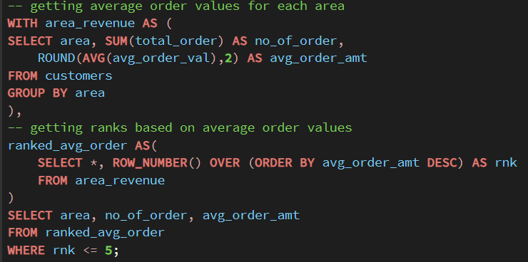

In order to get the average order values and sum for each area, the customers in the same area are grouped together using GROUP BY. Then, the SUM() function helps to find the total number of orders in each particular area, while the AVG() function helps to find the average order amount in the same area.

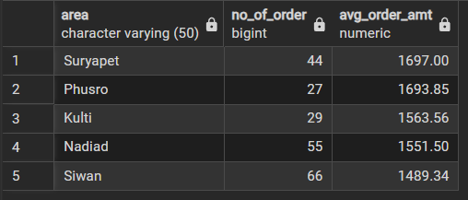

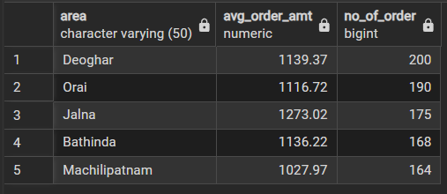

The first figure displays the top 5 areas with highest average order amount which reflects to the areas that generate the most revenue for Blinkit store. The second figure shows top 5 areas that has the highest number of orders, which reflects the number of times deliveries were made to those areas.

Once the top 5 areas for the highest average order amount and number of orders are identified, the next step is to examine the delivery performance in those areas via the delivery_time_mins column.

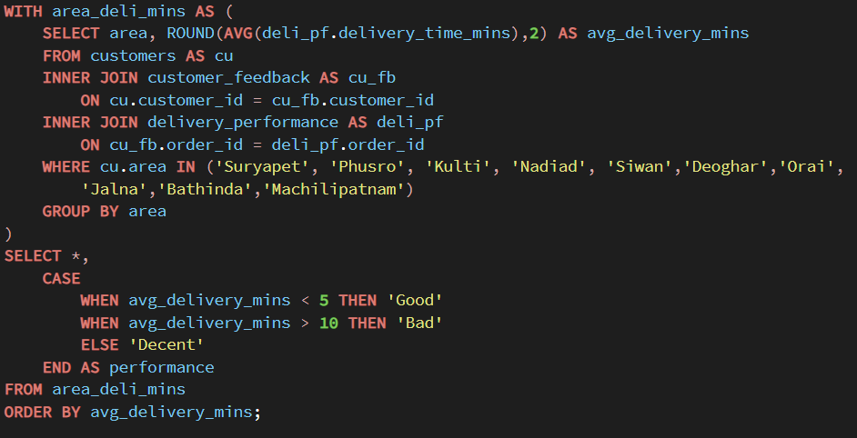

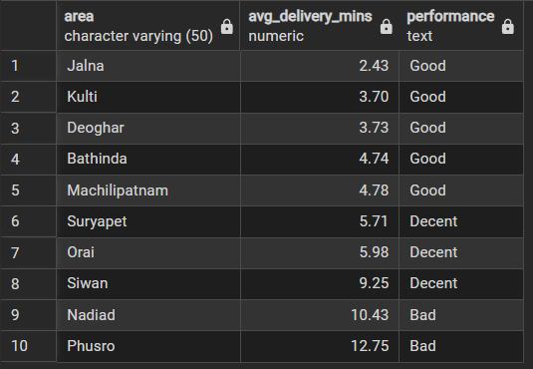

From the result shown, the areas with high number of orders have good delivery performance. None of the areas are labeled with “Bad” performance, where the actual delivery time exceeds the estimated delivery time by more than 10 minutes. However, in terms of the area with highest average order amount, there are two areas that have “Bad” performance. This is one of the aspects which Blinkit store may look into, and improve, which is to reduce the average delivery minutes in those areas.

Case 4 : Type of Products that are Selling and Not Selling in Year 2024 , and Type of Products with Highest Sales Growth from Year 2023 to Year 2024

This case study focuses on finding out products that are selling in year 2024 against the particular product sales in year 2023, as a metric to learn about the sales trend for the store. The goal is to improve the stock management for the warehouse, as identifying which products that are selling and not selling, can help Blinkit store to discern which product can support a higher or lower amount of supply for vendors and suppliers. In addition, the store can explore alternatives to the products that are not selling or find aspects to improve the sales on those products. Conversely, Blinkit store can also use the sales growth information to identify which products may continue to sell well in the following months or year.

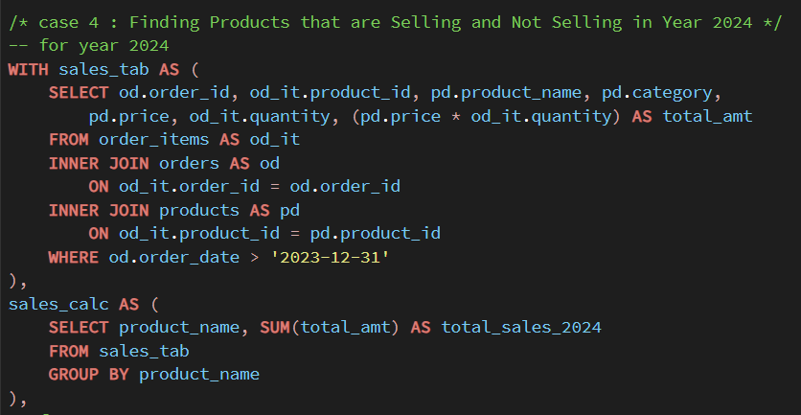

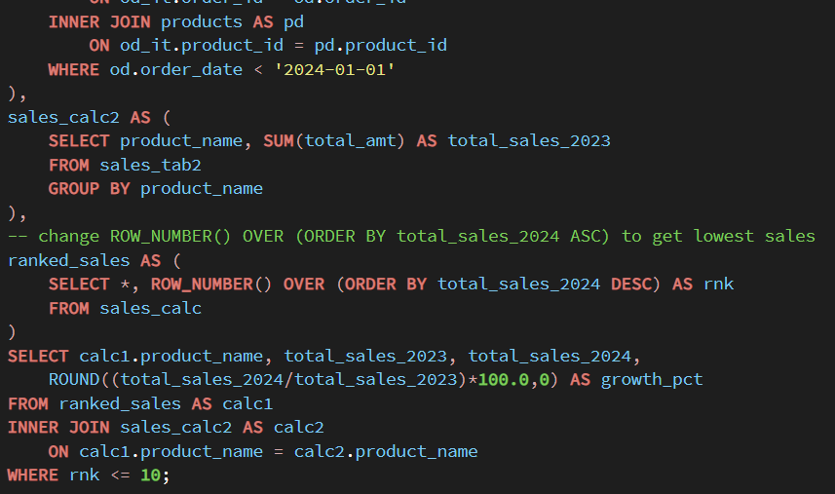

It is important for the store to not only know the products with highest sales in year 2024, but also the sales difference those products in the year before. Since the products that are highest selling may decrease in terms of sales it generated in the following year.

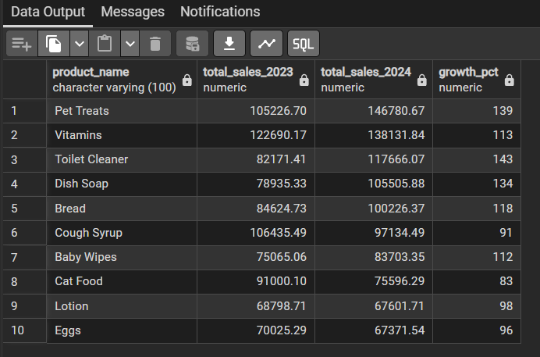

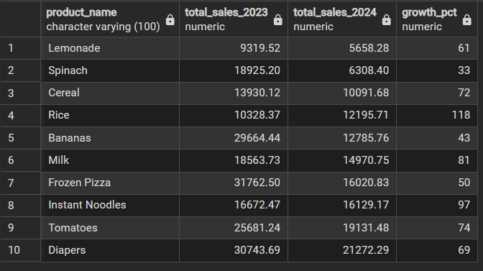

The first figure shows the top 10 products with highest total sales in 2024 and their sales in 2023. In general, most of the products have increase in the sales or maintained relative to the sales in the year before. The biggest decrease is recorded on “Cat Food” with 17% drop in total sales.

In the second figure, it can be seen that most of the lowest selling products still continue to decline in terms of sales. However, there is an exception in “Rice”, with a sales increase 18%. There are various reasons as to why the increase of this product.

Similarly, the store can also find the product categories that are selling and their sales growth.

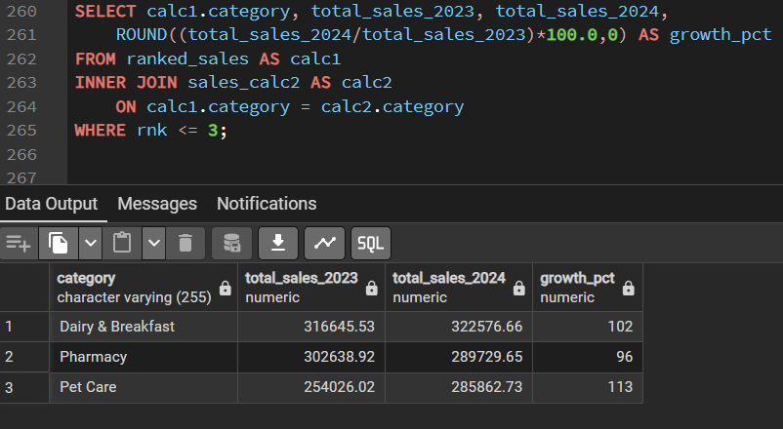

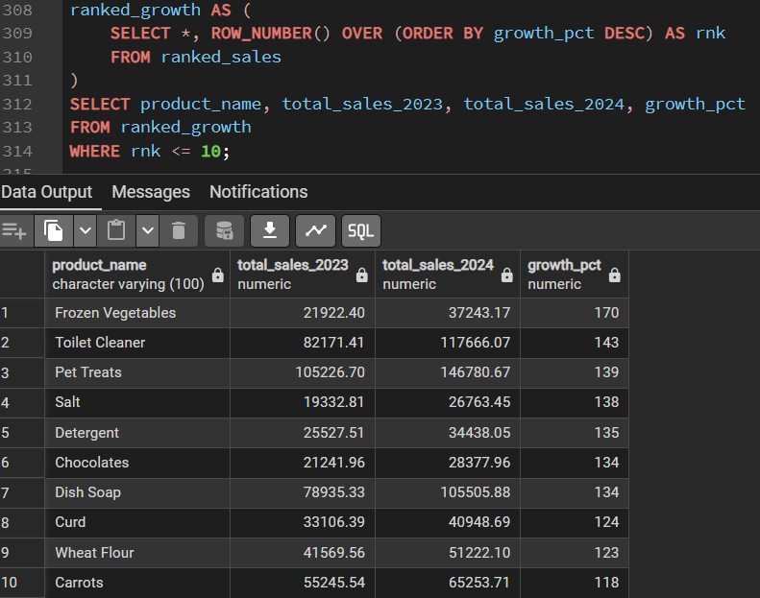

The figure above shows the top 10 products with highest sales growth from 2023 to 2024. This information is able to tell Blinkit store that these products might have the potential to increase in term sales in the coming months or year. In light of this, the store may increase the stock level for these products, while reducing the stock level for products that are not selling.

Case 5 : Top 3 Type of Products and Product Categories Order Rate for Each Customer Segment

This case study aims to explore the products and product categories that each customer segment are interested or attracted to in Blinkit store. This information helps the store to understand the customer behaviour in different customer segments when accessing their online store. This will help the store to pinpoint the type of products that the users in Blinkit store are interested in, as well as the market demand for certain products. Consequently, the store will be able to discover which products can support an increase in stock level, and also which product categories can carry more products.

By implementing PARTITION BY customer_segment, the customer segment can be grouped without collapsing the product_name rows. The customer segment label is given a priority in terms of their order in the table result from “Premium” to “Regular” to “New” and finally “Inactive”. The prioritization is a guess based on the importance of the customers to the store.

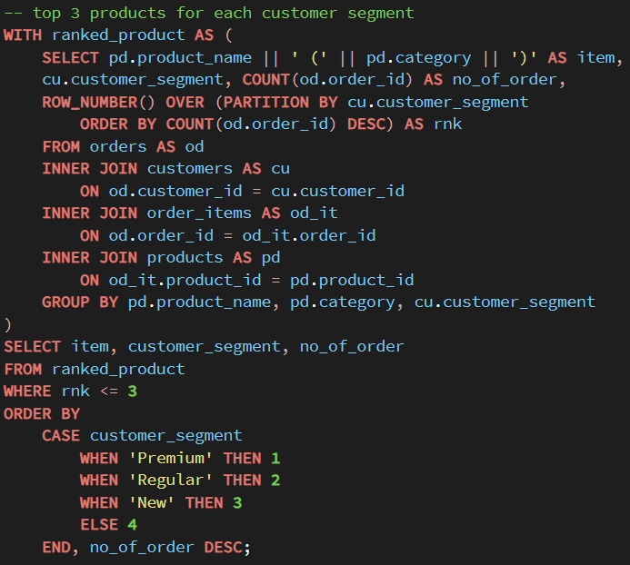

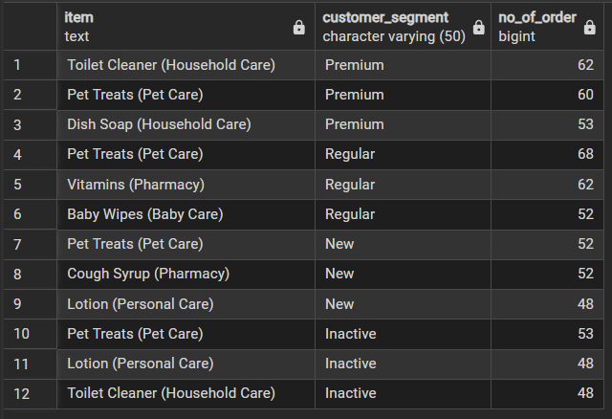

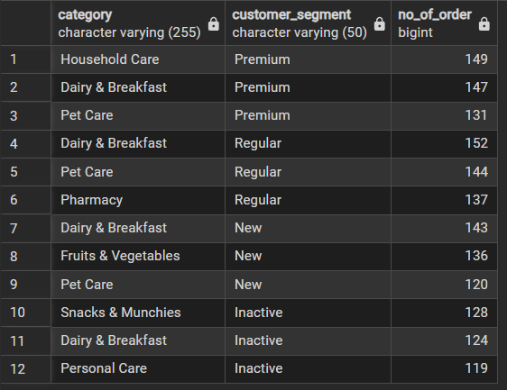

Based on the the first result, there is a common product that is present in every customer segment which is “Pet Treats”. This means that in general “Pet Treats” from different brands have a lot of orders.

From the product category result, evidently “Pet Care” category also appeared in almost every customer segment besides “Inactive”. This means that in general, pet based products sell well in Blinkit store. Moreover, “Dairy & Breakfast” category appeared in every customer segment which indicates that products in this category are often ordered, or the store has a high volume of stock for this category, or various products from many brands for this category, as Blinkit store is primarily a grocery store.

Case 6 : Engagement Rate for Marketing Campaign Held in Each Channel in Year 2024

The goal for this case study is to identify the engagement rate for marketing campaigns held in each channel for all target audiences in the Year 2024. Engagement rate in marketing is able to tell Blinkit store how successful their marketing strategies are in the year 2024, on each channel comprising of “Email”, “App”, “Social Media” and “SMS”. This means that Blinkit store will be able to pinpoint the channel to advertise in future marketing strategies for each target audience, as well as which channel needs a different marketing approach.

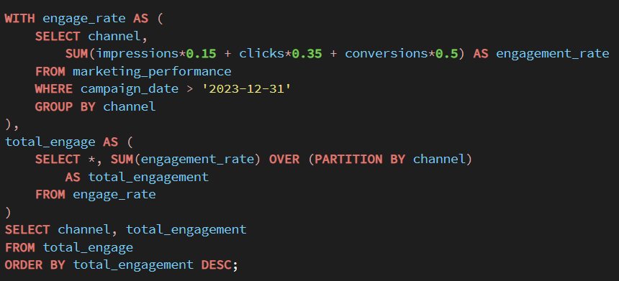

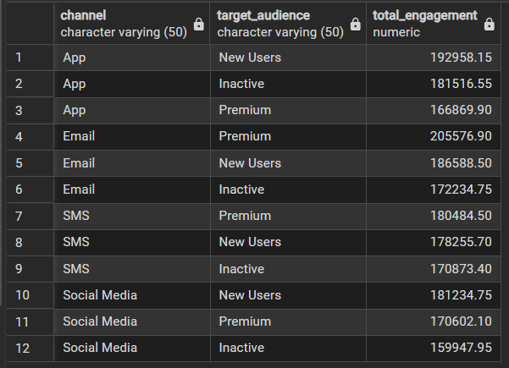

In the engagement rate calculation, impressions are given the lowest weighted sum of 15% mainly because impressions usually does not mean much without further actions like retweets, likes etc. Clicks is given a 35% due to a more engaged action, and conversions is given 50% because this mean that the customer actually ordered or purchased something based on the marketing campaign initiatives.

The result here displays the total engagement during the marketing campaign with the target each audience in every channel. Based on the result, the more trendy or adopted methods of “App” and “Social Media” in current generation have more impacts on “New Users”, whereas older channels of “Email” and “SMS” are able to attract engagement on “Premium” users potentially due to newsletter sign-up.

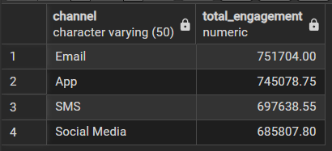

Based on this result, it can be deduced that the biggest portion of engagement from customers in Blinkit store belongs to “Premium” and “Regular” customers. This could also mean that the age group of customers in Blinkit store are young adults and middle age. This is in light of “Email” and “App” having the top 2 spots for total engagement rate in the channels department.

Case 7 : Overall Campaign Effectiveness on “New Users” and “Inactive” Customers for “App” and “Social Media” channels

The focus of this case study is to find out the overall campaign effectiveness on “New Users” and “Inactive” users on “App” and “Social Media” channels. The average profit gained is used as the focal point to determine the campaign effectiveness. The profit gained is achieved by using the average of revenue from campaign against the cost / amount spent for the campaign operations.

The reason for this case study is mainly for Blinkit store to identify the campaign effectiveness on modern channel trends among “New Users” or customers who are yet to be aware of Blinkit store existence. This does not mean “Email” and “SMS” are an outdated medium, as it is dependent of the geographical location of the business. Moreover, it is also important for Blinkit store to identify right the marketing strategies to implement in order to maintain customer retention, and reduce the number of “Inactive” users.

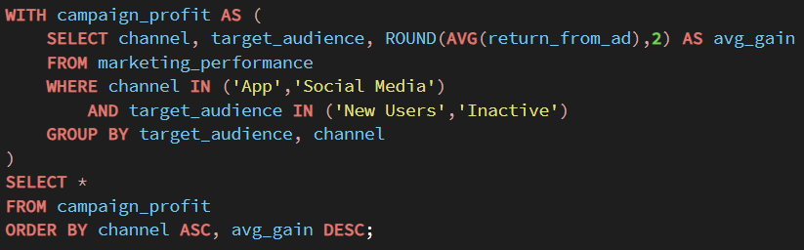

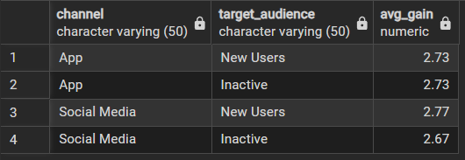

Based on the result above, “Social Media” has a slight advantage in terms of average profit gain over “App” for “New Users”, and vice versa for “Inactive” users. This means that “App” based marketing may be more suitable towards “Inactive” users, while “Social Media” may be more tailored for “New Users”. However, in “App” channel, both target audience categories returned an identical profit gain. This could also indicate that potentially by limiting campaigns on “App” and increasing “Social Media” campaigns for marketing, both “New Users” and “Inactive” users would contribute to the revenue gain. This in turn reduce the overall amount spent for campaigns while increasing the profit gain.

Case 8 : Stock Info for the Latest Year (2024) for Top 3 Products for "Regular" and "Premium" Customers based on Order Total in Store

This case study focuses on finding the stock information in 2024 for top 3 products by regular and important customers to Blinkit store. The goal of this study is to help Blinkit store to identify and manage stock levels for sellable products from the store. It is significant for an online store to manage their inventory to generate smooth inventory movement from supplier to warehouse, and also maintain a consistent growing profit on their products.

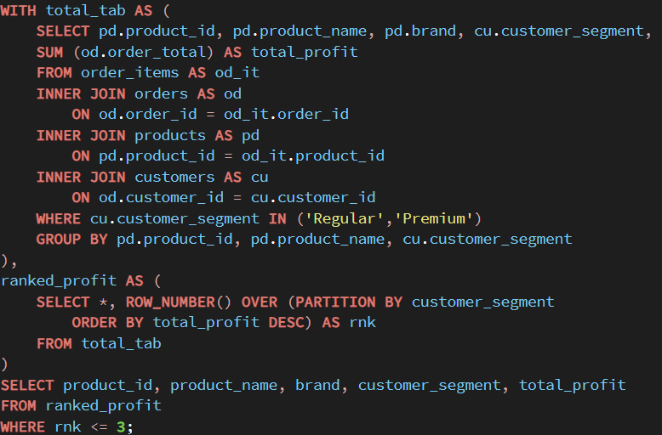

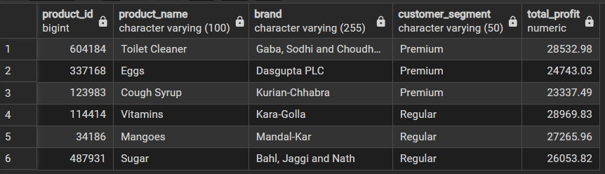

The result shows the top 3 products for “Premium” and “Regular” customers based on the total profit in Blinkit store.

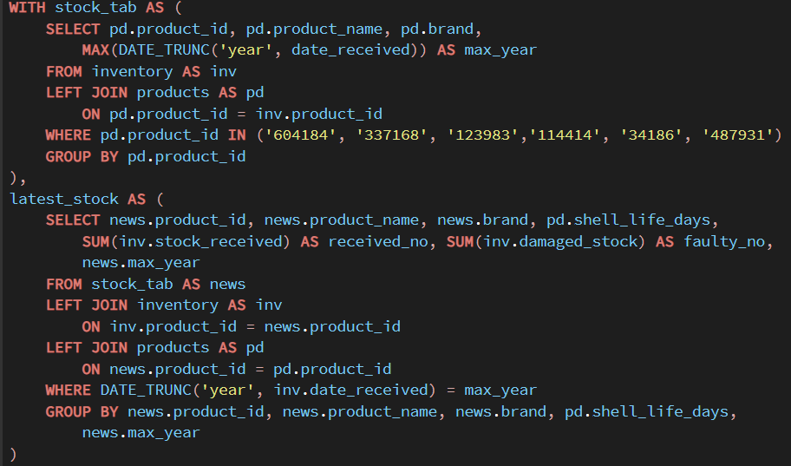

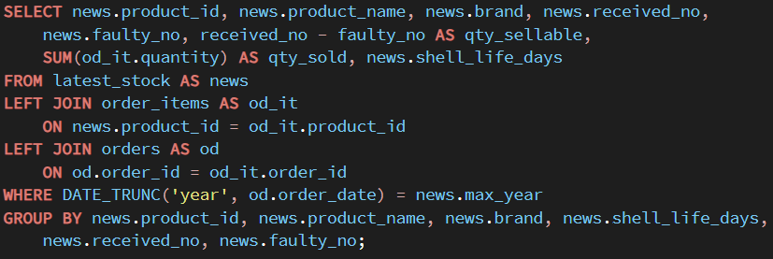

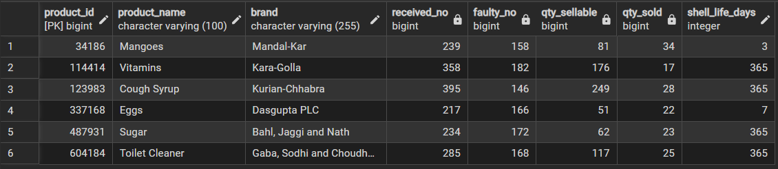

Blinkit store can use this stock information for their selling products to group their stock management performance. For instance, if the difference between the quantity sellable and the quantity sold given the duration of the shell life is big, then the particular product despite being one of the most sellable product, can reach a higher sales profit. It is also important for Blinkit store to set a maximum acceptable quantity for products that are faulty for products with different duration of shell life. This is important because brands or stock received that are faulty can negatively impact to the profit generated by the store, as the expenditure increases, having to purchase more to cover up the remaining faulty numbers.

**Exploratory Data Analysis Visualizations (Excel / WPS)**

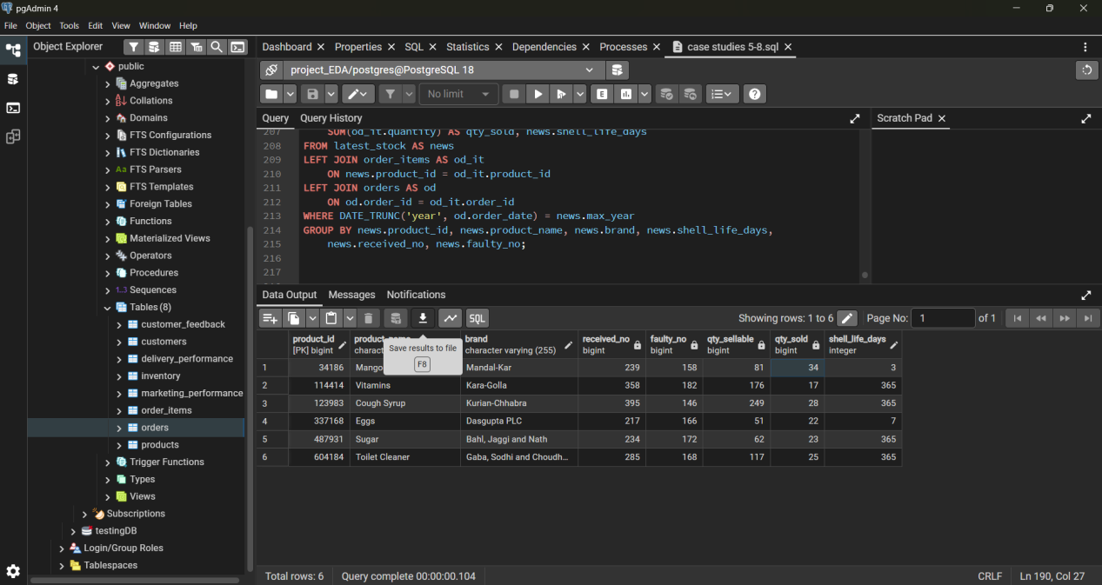

Once all the specific exploratory data analysis have been done, the results are exported to .csv files. The visualizations for the case studies are performed in Excel / WPS environment.

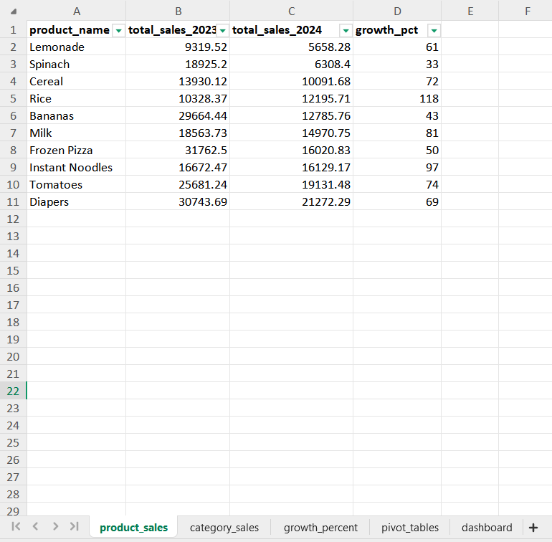

All the query results which are saved in different .csv files are imported into Excel .xlsx files according to the respective case studies. Then, sheets are created depending on the number of SQL query result tables.

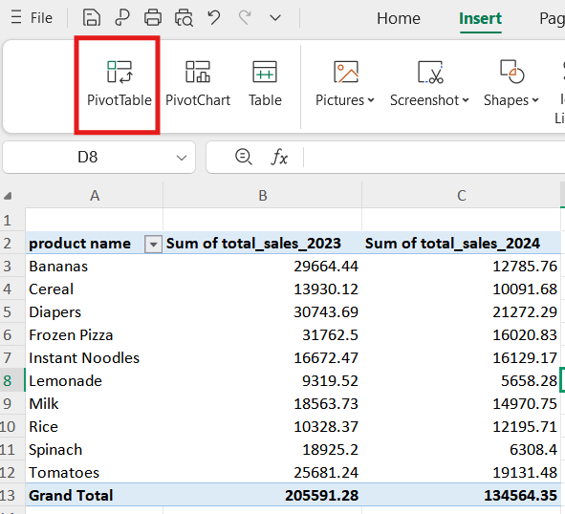

Once all the sheets are created, pivot tables for each table are created in the “pivot_tables” sheet. These pivot tables contain data that are used in graphs and information for the dashboard.

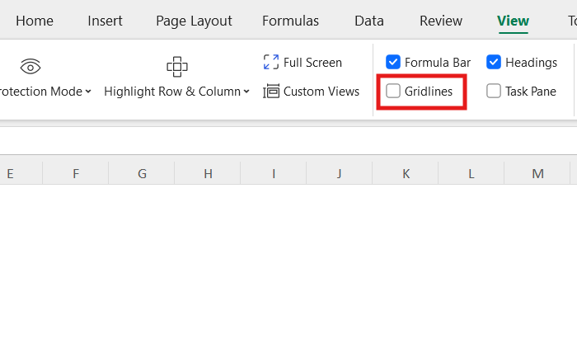

In the “dashboard” sheet, the gridlines option is unchecked to remove gridlines in Excel /WPS.

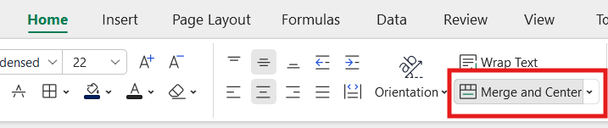

The dashboard title has cells that are merged and centered.

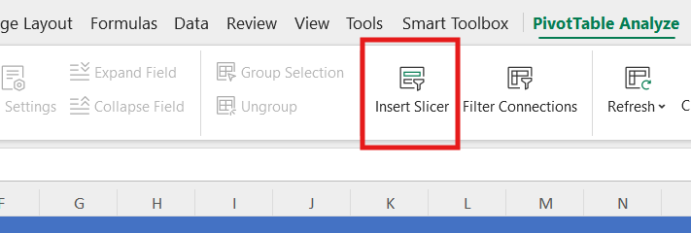

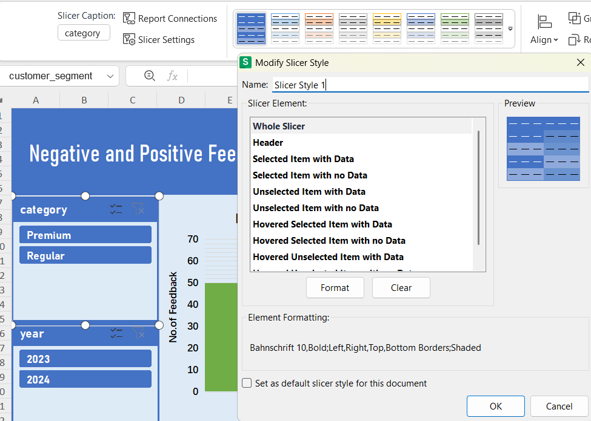

The graphs and charts are created via the pivot tables table. Once, the graphs have been created, slicers are inserted to give the graphs interactive features to view information in different ways. The slicers are given custom styles to match the dashboard background to make it easier for viewing, and a more uniform design.

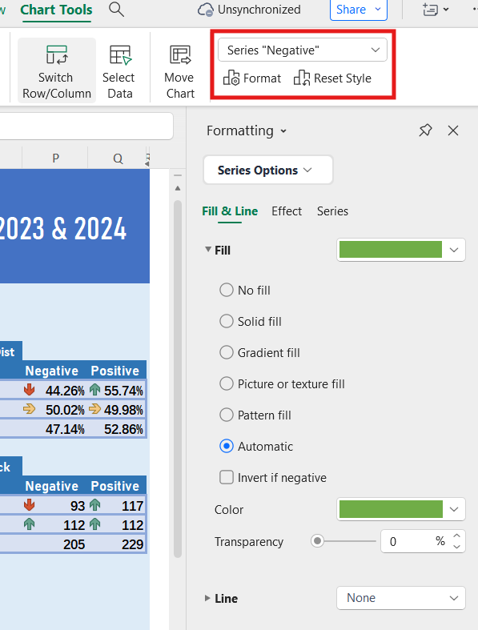

The plotting and graph chart formats are edited through accessing each individual format property available via the “Chart Tools” tab.

**EDA Dashboards**

Case 1

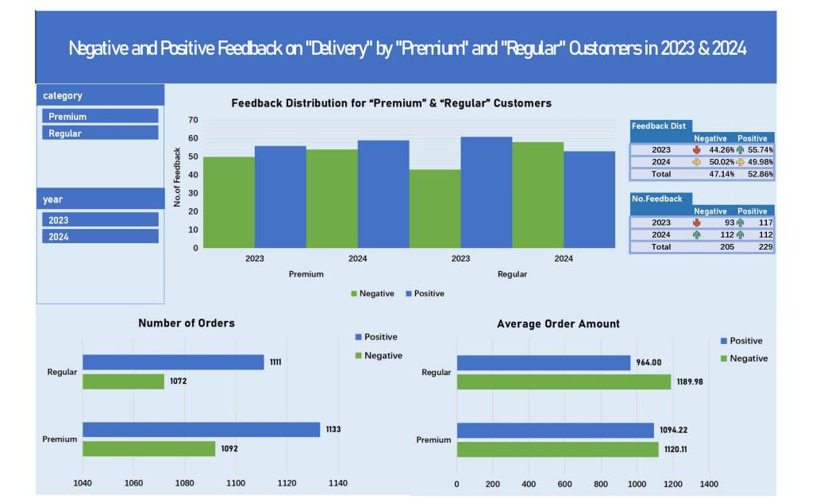

Case 2

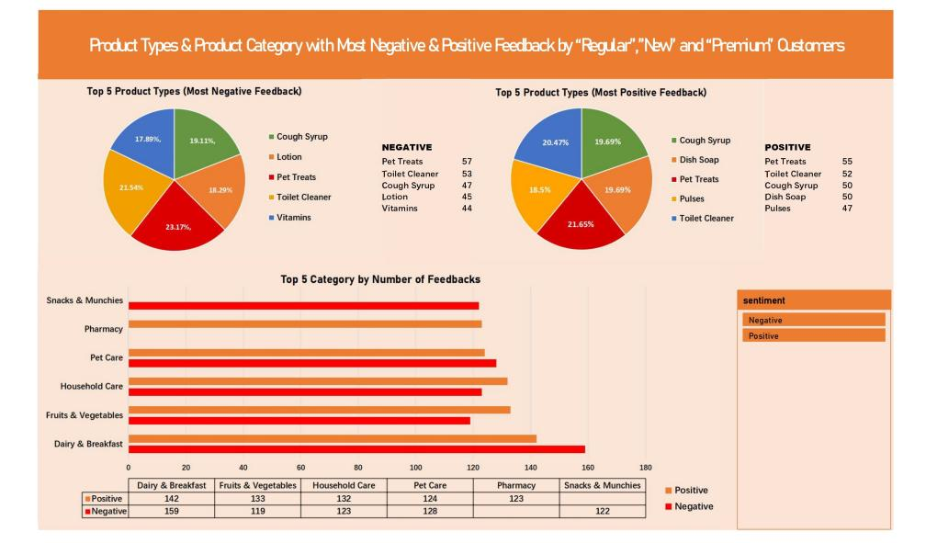

Case 3

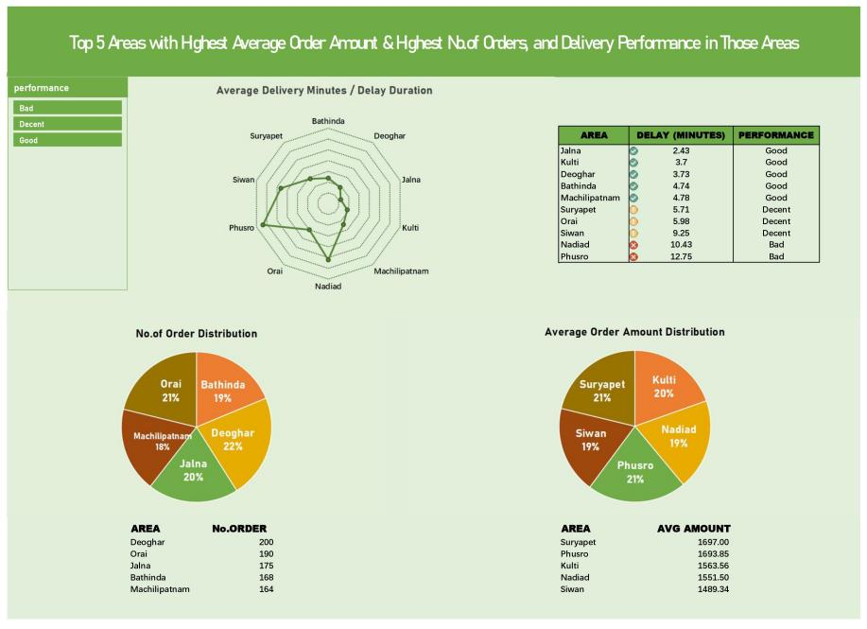

Case 4

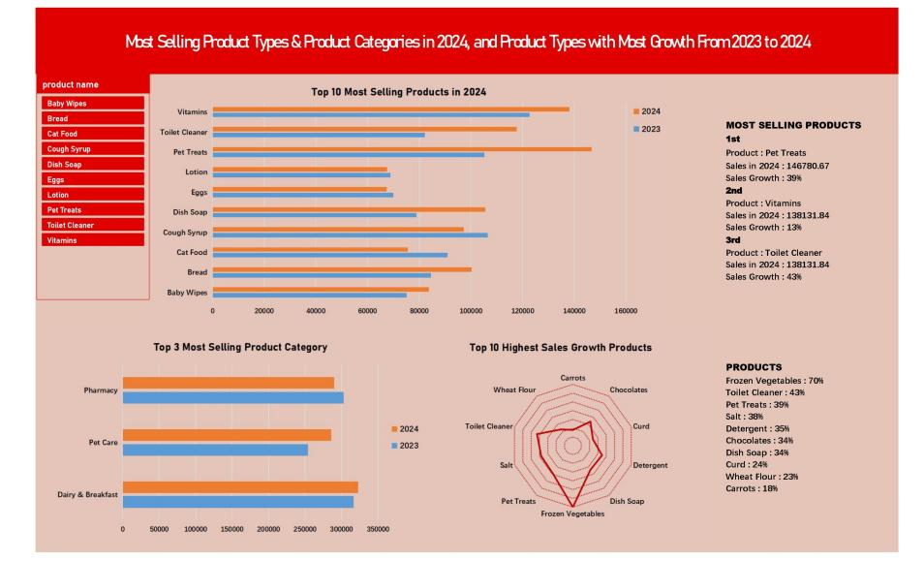

Case 5

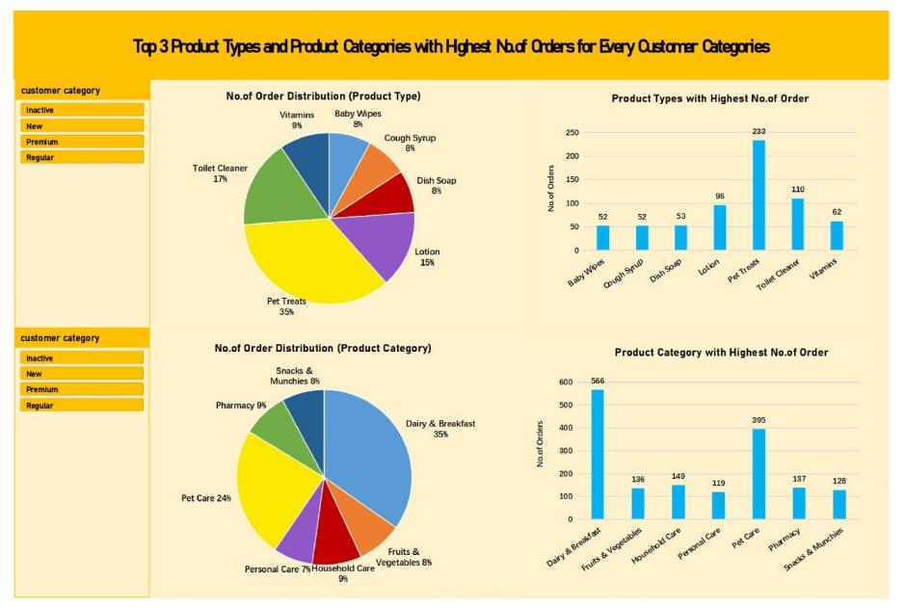

Case 6 & Case 7

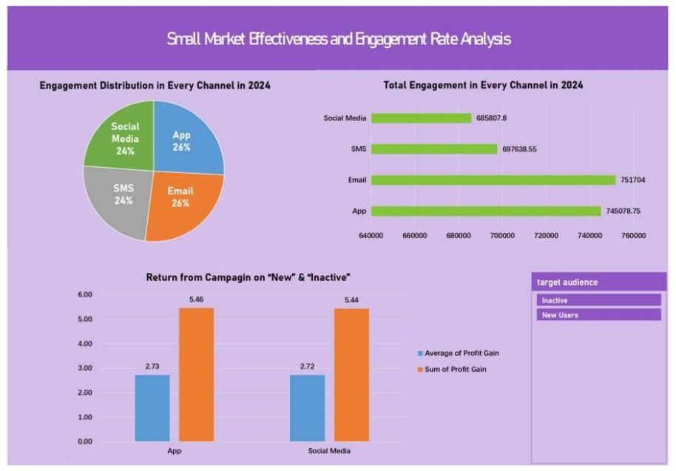

Case 8

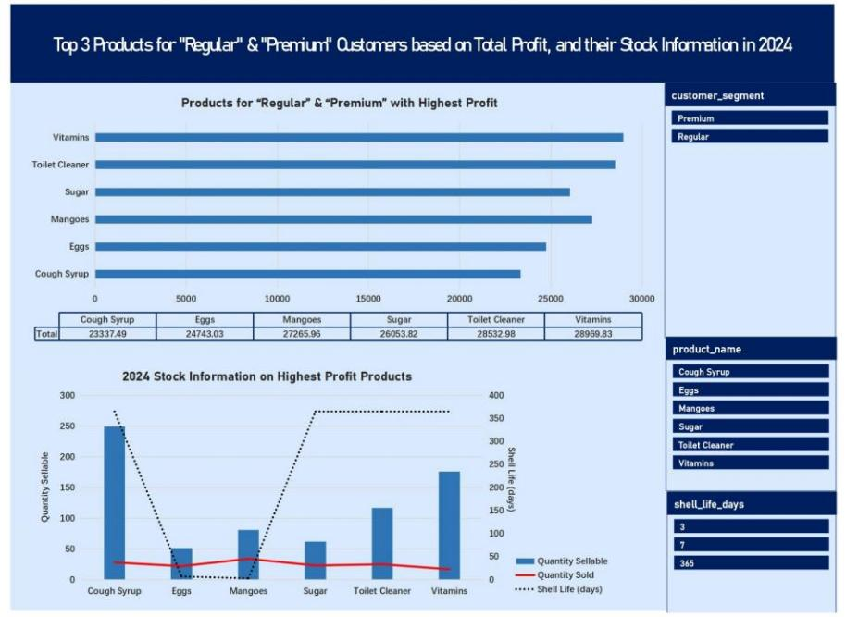

**Data Processing for Natural Language Processing (PostgreSQL / Python)**

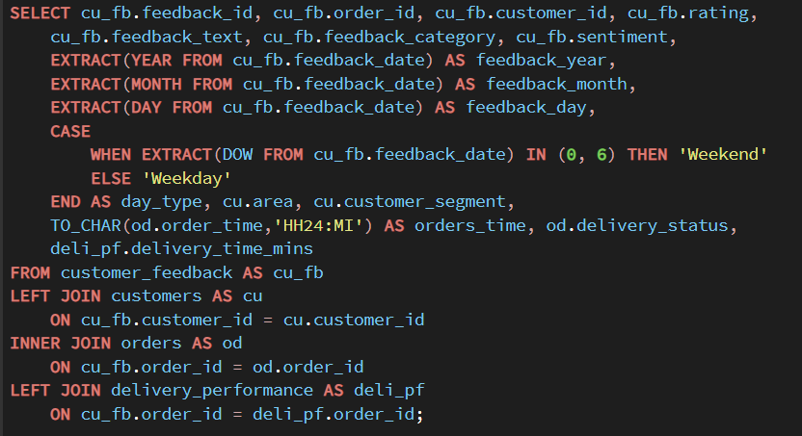

Initially, the features or columns that can influence sentiments by customers are transformed and processed into columns for analysis. Years, months and days data are extracted from date column as those data are useful for time-series based analysis for sentiments. Day of week is also processed to obtain ‘Weekend’ and ‘Weekday’, as this information may also influence sentiments. The order time data in which feedback are made, are also obtained as a feature for time-series analysis. Areas of customers data are also taken, as geographical analysis on sentiment may prove to be insightful. Finally, the delivery delay duration and the labels for delivery status are also taken, as delays usually correlates to “negative” sentiments, and the delay duration can be used as a benchmark for the type of sentiments the customers in Blinkit gives.

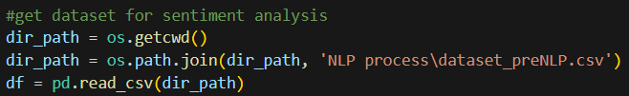

Once, the dataset can be processed, it is then imported into Python environment. Since the customer feedback data table originally had ‘rating’ and three classification types for sentiments, the type of model used for sentiment analysis should also fulfill these conditions. In order to more accurately define if feedback are actually “positive”, “negative” or “neutral”, a transformer is decided as the type of natural language processing to be used. These requirements are fulfilled by the NLPTown’s BERT model. The main downside of this model is that, since, the data table only comprises of 5000 records, it still take a longer processing time, when compared to VADER, DistilBERT and other NLP models.

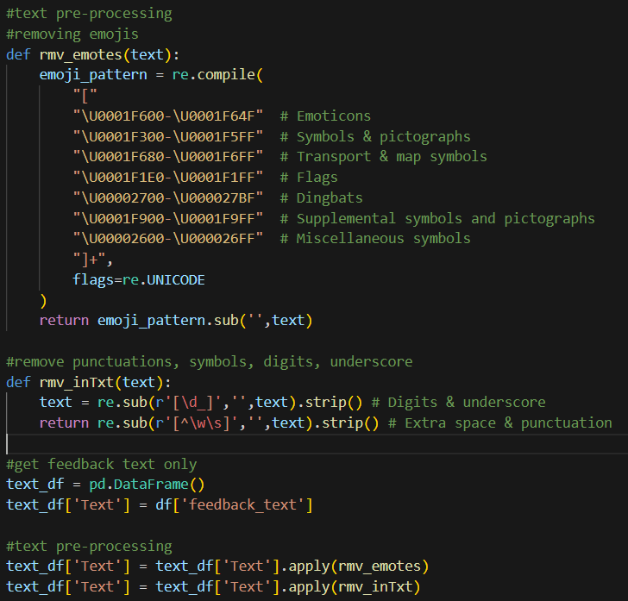

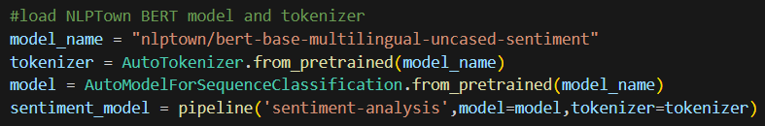

Before the feedback texts can be passed to the model, some pre-processing must be done. For example, the emotes, symbols, extra spaces, digits and punctuations should be removed, in order for the model to accurately identify the sentiment for each feedback text.

Since the model that is used is of transformer type, there is no need for lemmatization and removal of stopwords. This is because BERT, unlike VADER, reads natural texts in bi-directional. This means that it is able to capture the essence of the sentence meaning better than model like VADER, which only reads sentence from left to right. For instance, in sentence, “The product was okay, but the delivery was really slow.”, naturally at first glance, is would be deduced as “neutral”. The same can be applied to the transformer type result, where it outputs “neutral”. However, in lexicon-based models, “slow” in the sentence is viewed as negative, consequently, it outputs “negative”.

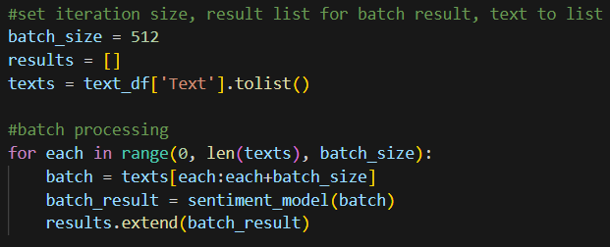

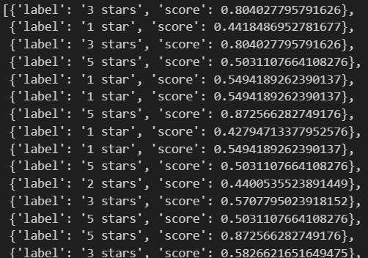

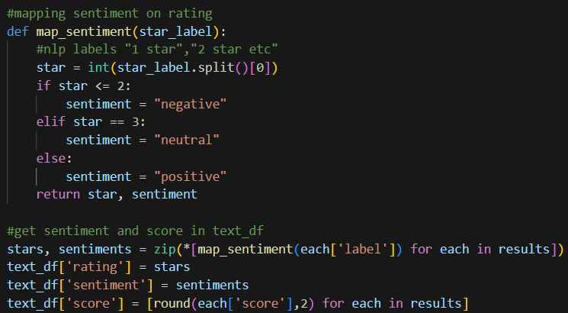

In order to manage to CPU usage well, the texts are passed in batches of 512 size each. The results from the batch are stored into a separate list. Once the results are obtained, the “sentiment” and “rating” columns are defined and processed from the results. NLPTown’s BERT model outputs result in form of “1 star”, “2 stars”, up to “5 stars”. Therefore, for “rating”, 1 and 2 are labeled as “negative” sentiment, 3 is labeled as “neutral”. The rest are labeled as “positive” sentiment.

**Training Logistic Regression from Sentiment & Rating Labels from NLPTown’s BERT (Python)**

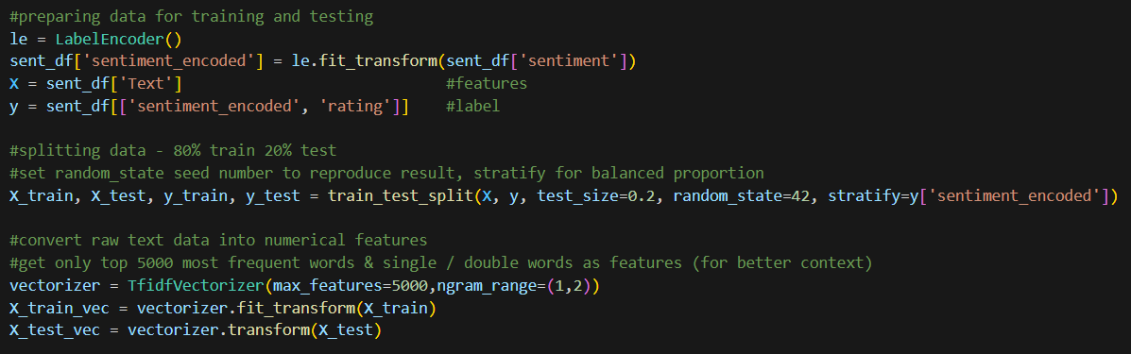

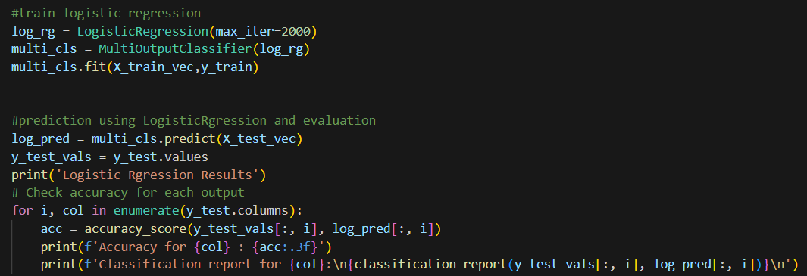

The machine learning model used for training and testing is a combination of Logistic Regression and MultiOutputClassifier. The base model is Logistic Regression model, which estimates the probability of sentiment occurrence, whether it would be “neutral”,”negative” or “positive”. Logistic regression algorithm usually outputs 0 and 1. For instance, in cancer detection, logistic regression model returns 1 for patients with cancer potential, and 0 for patients with no potential for cancers. It works well with classification issue, which in this project case, fits well. The dataset used revolves around classify ratings from 1 to 5, and sentiments in the form of “neutral”. “negative” and “positive”. Therefore, logistic regression is chosen.

In order to train a logistic regression model, the dataset is split into categories of 80% for training, and 20% for testing. First, the “x value”, which is the learning material, are the texts, which are vectorized from raw texts into numerical features. Then, “y value” is the expected outcome, which in this case takes both “rating” and “sentiment”. Hence, the need for MultiOutputClassifier. Usually, logistic regression can only take 1 feature, and have 1 label/output, but with the help of MultiOutputClassifier, more than 1 output can be generated from a feature.

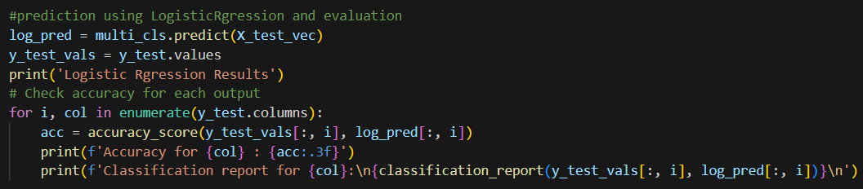

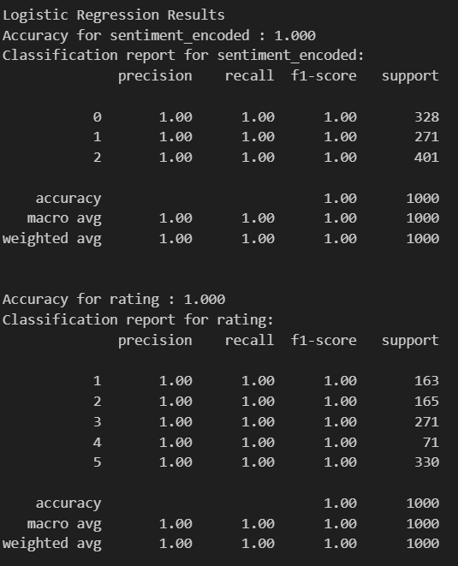

Since the labels were generated from a BERT model (NLPTown), the classical machine learning model, logistic regression effectively learned to replicate the BERT sentiment and rating mapping. This resulted in the perfect accuracy. However, hyperparameter tuning was still performed to validate model robustness and ensure optimal generalization.

**Model Tuning and Predicting on Blinkit dataset (Python)**

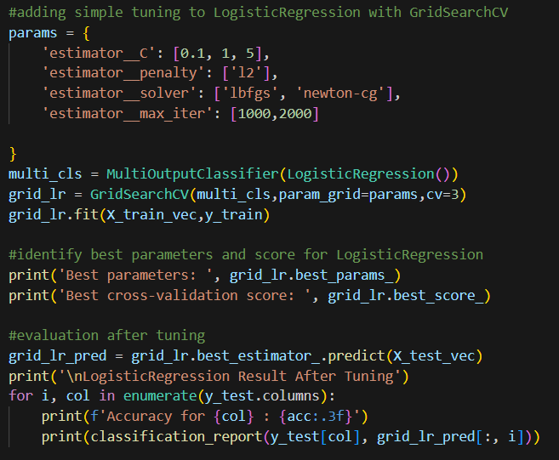

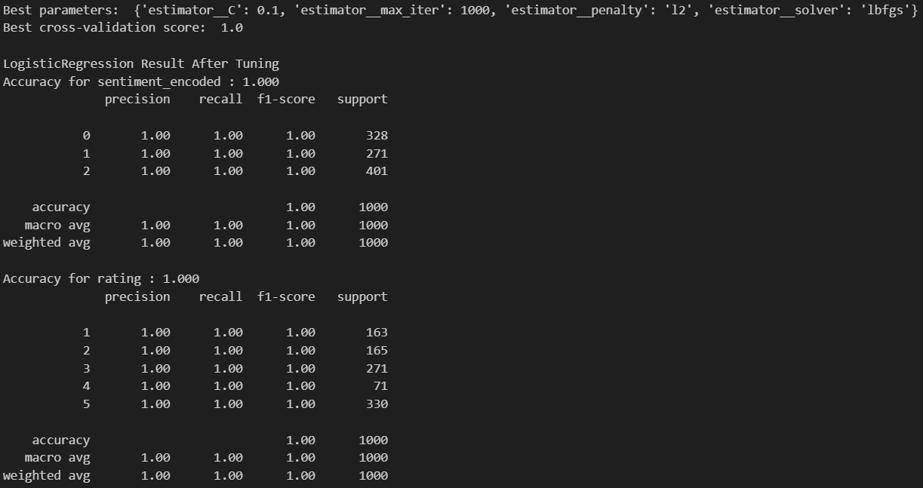

The model is given a parameter grid with multiple different parameters, and using GridSearchCV to test different parameter combinations in order to find the best score for predictions. Then, the best estimated parameters are used to predict on the test data defined, and the results are evaluated.

Similar to previously, the result accuracy was perfect, and did not drop. This confirms that the model is robust enough to predict the actual feedback texts in Blinkit dataset. This is mainly due to the ability of logistic regression to copy or learn from the NLPTown’s BERT model.

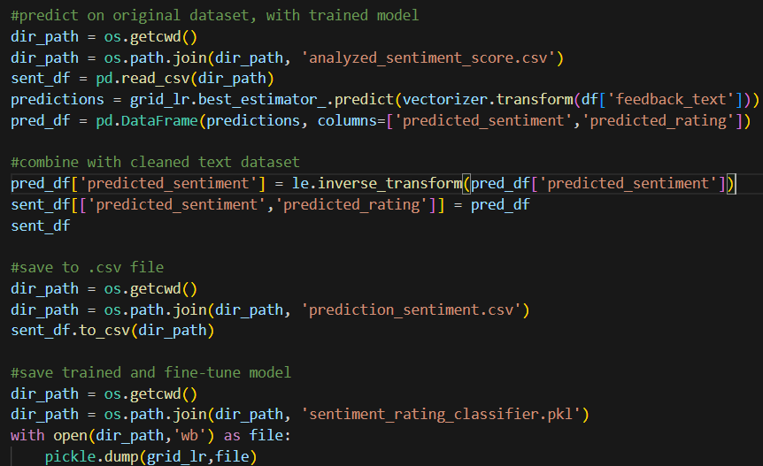

The hyperparameterized and tuned model is used to predict sentiment and ratings from the feedback texts from customers. The results are then stored into a dataframe and exported to a .csv file. The trained and prediction logistic regression model that was used, was also saved in .pkl file.

**Correlation Analysis of Sentiment against other Features (Python)**

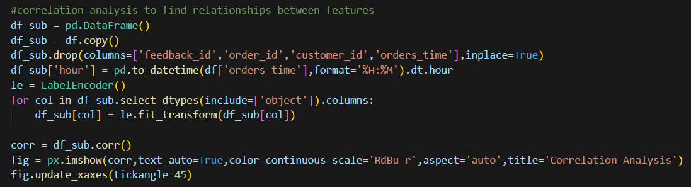

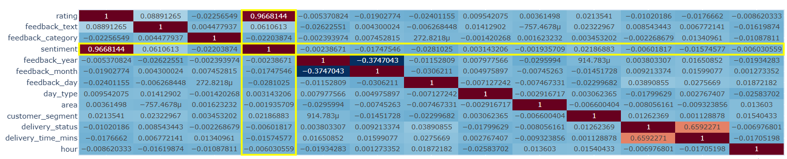

Initially, a correlation table is created to check on which column or feature influences the sentiment label in this dataset. Based on the result shown, only rating showed a very strong correlation to sentiment. However, this does not mean that other features or columns do not influence the sentiment label. Hence, more analysis must be done to the other features. The relationship between sentiment and other features analysis, however are not done in this project.

**Sentiment-Feedback Distribution Analysis (Python)**

This project only aimed to analyze features with sentiment and feedback by utilizing the fine-tuned model’s prediction.

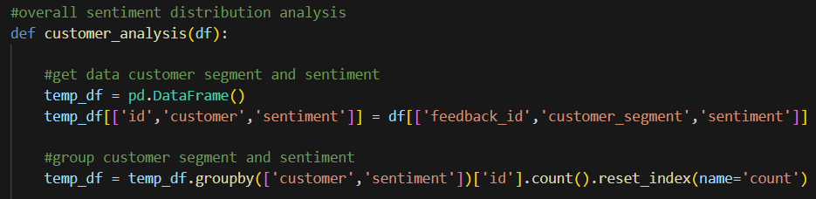

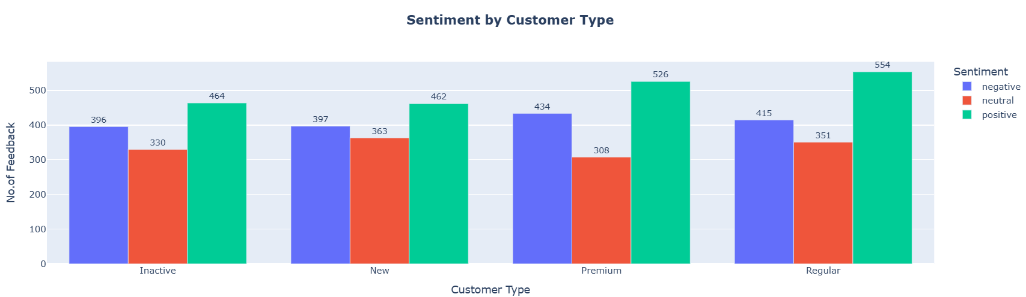

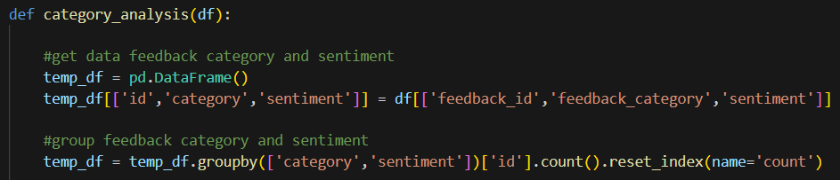

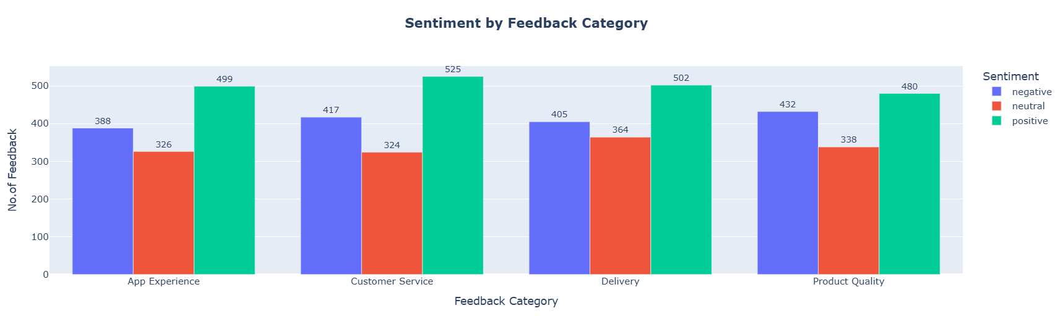

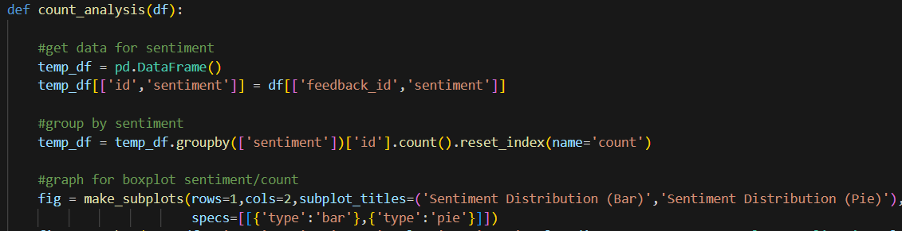

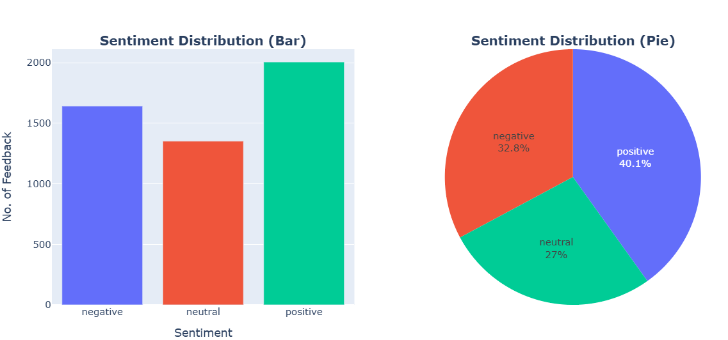

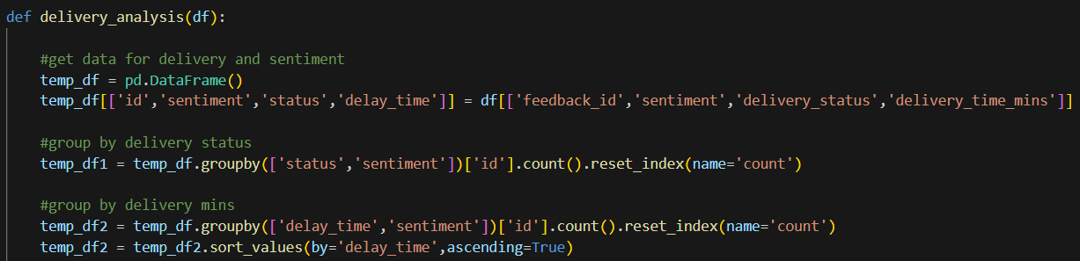

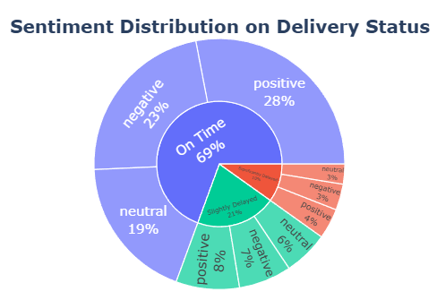

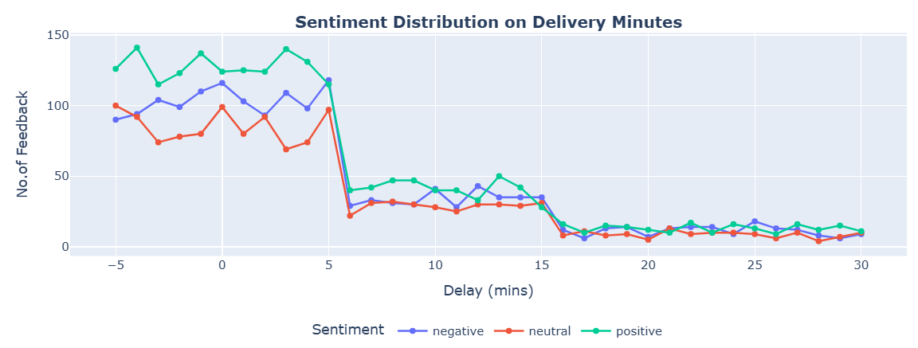

First of all, the sentiment distribution among customer segment, feedback category, the overall data count in feedback and the delivery are visually identified. It is important for Blinkit store to recognize sentiment distribution on their feedback as a key for evaluating their store’s performance, as well as a key for understanding the need to improve on areas to maintain customer retention.

**Time-Series Analysis (Python)**

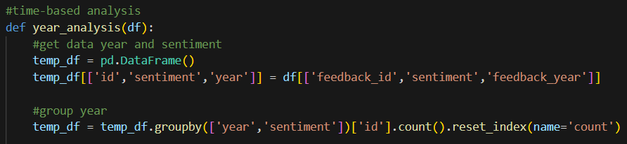

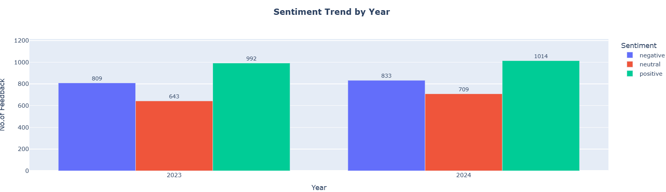

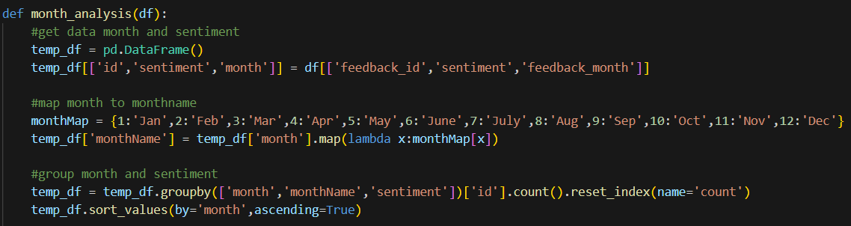

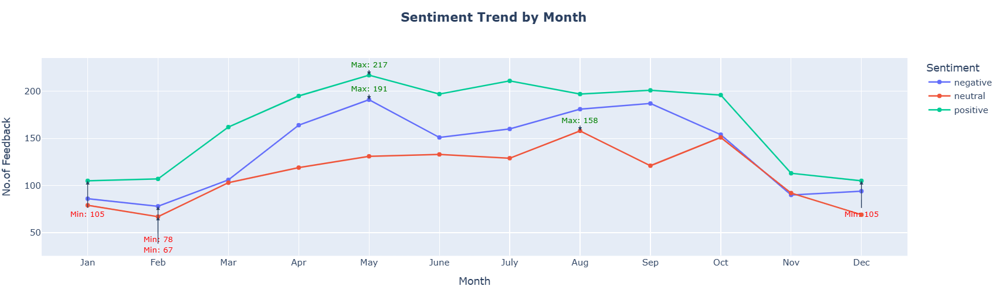

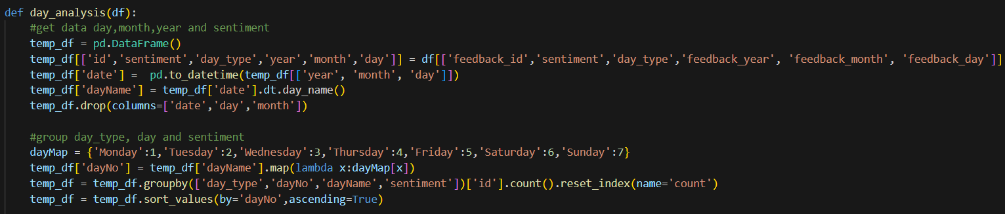

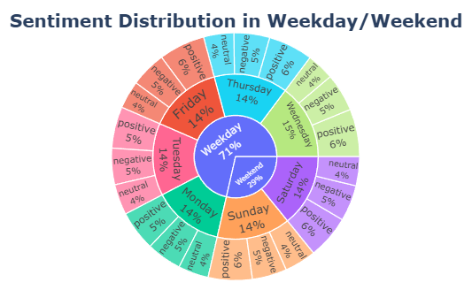

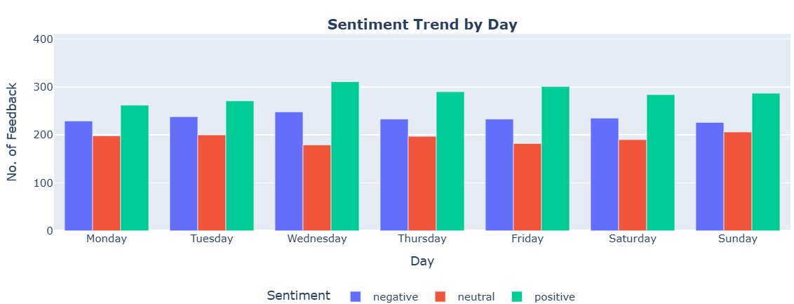

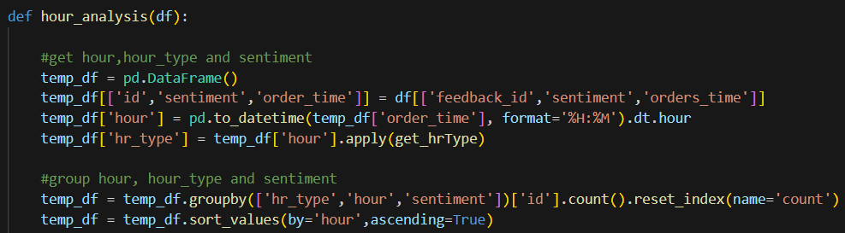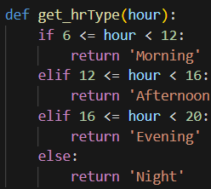

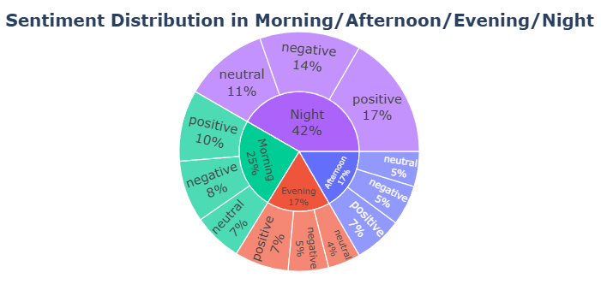

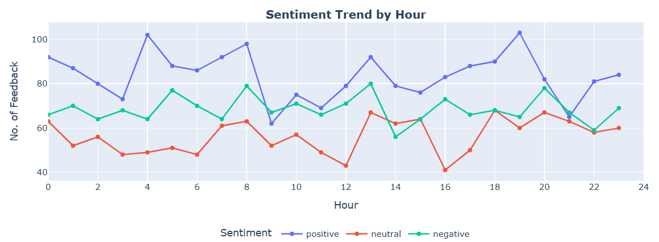

Analysis on time-based features can help Blinkit store uncover customer behaviour across different time periods, as well as identify seasonal trends. For example, the number of feedback shown in the line graph of sentiment trend by hour is high in between 7.00pm and 8.00pm, and 4.00am. On one hand, the first interval of 7.00 - 8.00pm can be understood as a time where maybe little traffic occur, consequently, leading to fast deliveries, which translates to positive feedback. However, it could also mean that the products are mostly fresh or newly published during this hour, leading to good product reviews. It is a more obvious trend that can be interpreted into various possibilities. The second interval, 4.00am, on the contrary, is an interesting trend that could be ventured and analyzed.

**Geographical Analysis (Python)**

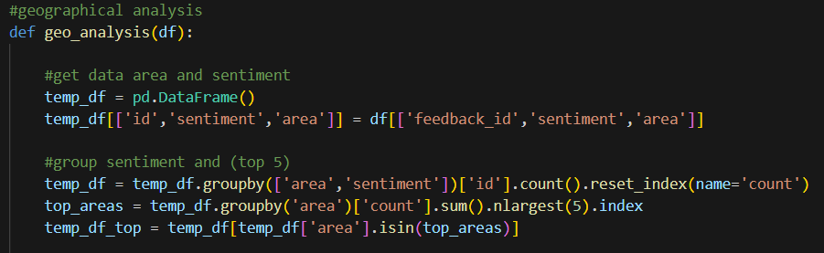

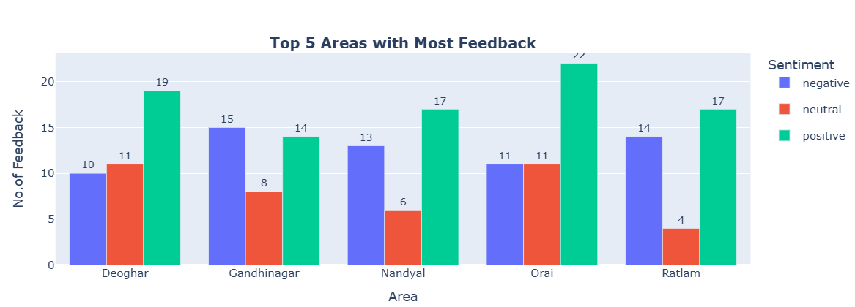

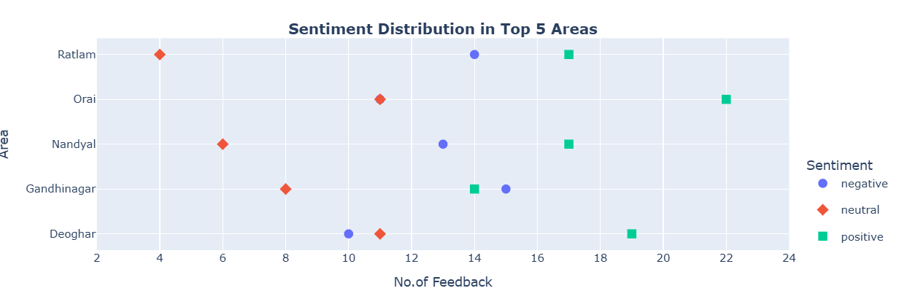

Geographical sentiment distribution is a significant area to study as it helps Blinkit store to identify the responses given by the most order frequency locations, and the most engaged customers territory in the store. This means that these area cover a large portion of Blinkit customer base, as well as the profit. A large number of negative feedback will indirectly inform Blinkit on whether there are delivery issues, for example, the product received is not well packaged on bumpy roads, delivery delay time causing the product to turn bad etc.

**Word-based Analysis (Python)**

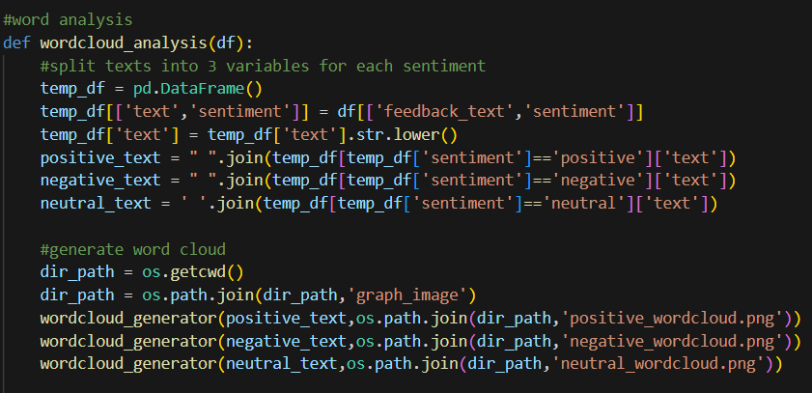

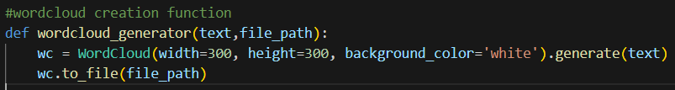

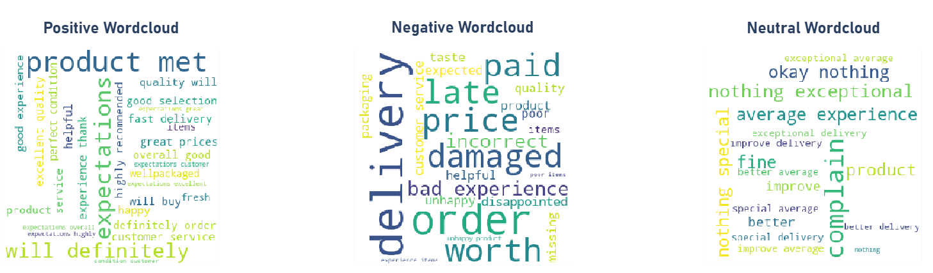

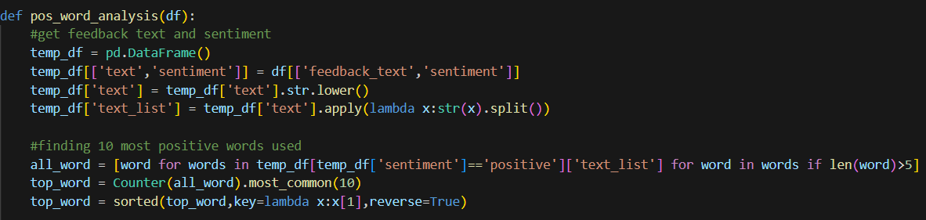

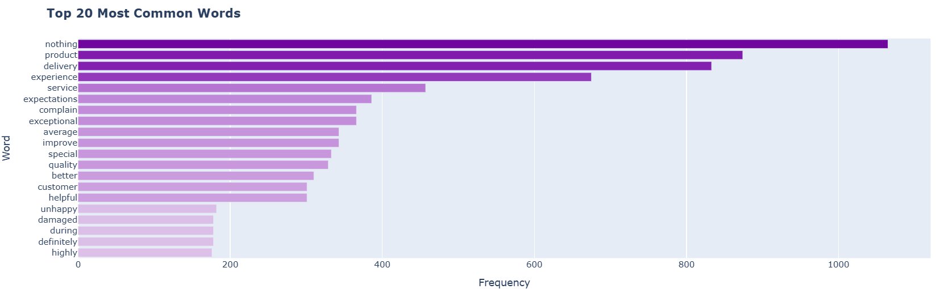

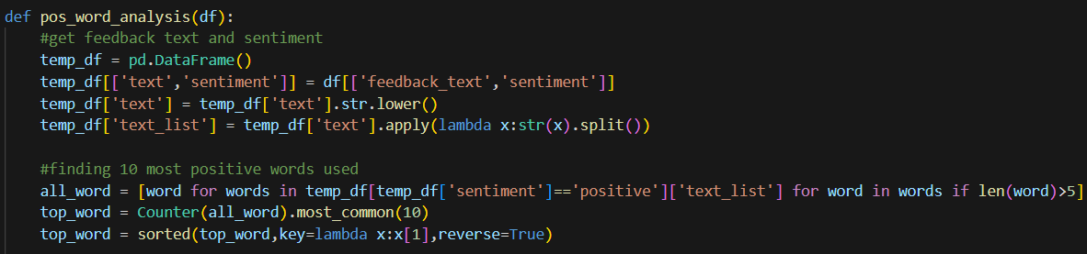

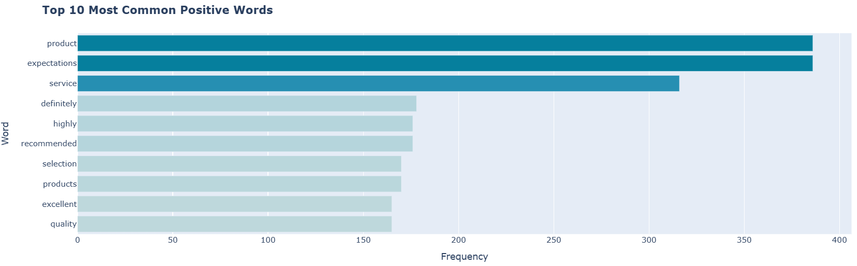

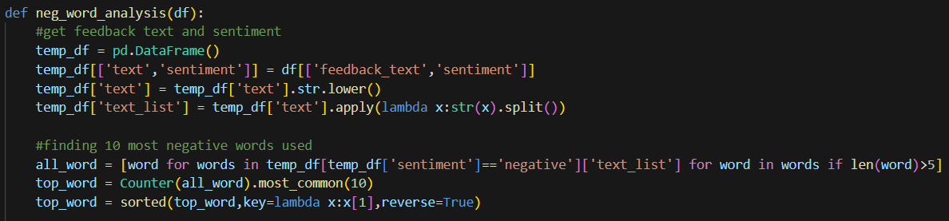

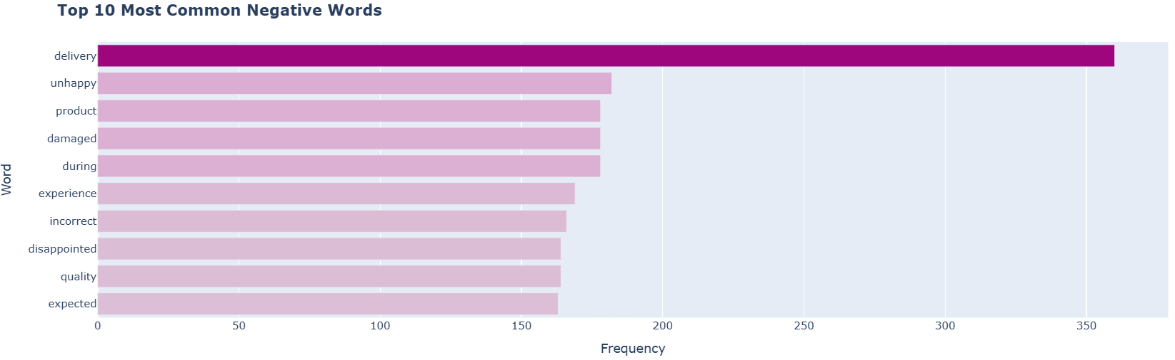

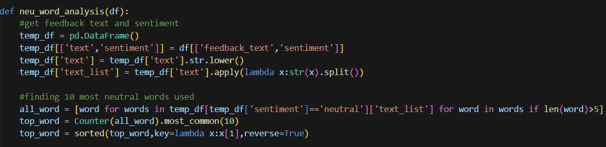

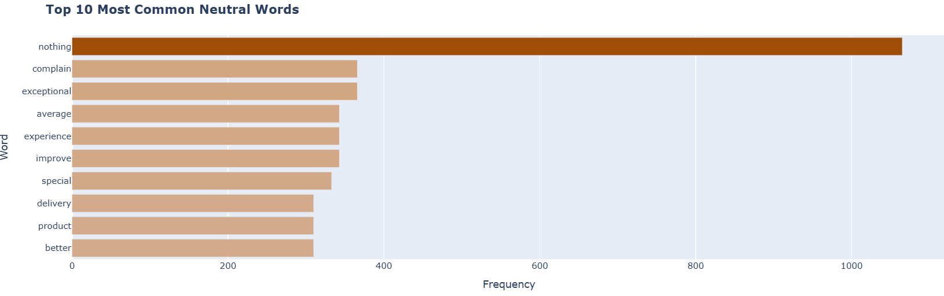

Investigation on feedback text can be usually to gain insights on Blinkit store existing strength and weaknesses. In this section, the word length is set to words exceeding 5 because for feedback texts, there are multiple sentences that comes with “very”, “good”, “bad” etc, which are not meaningful. Based on the result, the most common positive feedback shows “product” which means Blinkit generally keeps a good standard in terms of getting reputable product, as well as managing product. On the contrary, the most common negative feedback shows “delivery” as an area in which Blinkit store can look into to improve.

**Dashboard for Sentiment-Feedback Analysis (Python/Dash/CSS)**

The dashboard is created using a mix of Python, Dash, CSS and HTML. The goal of this section focuses on applying interactive features on dashboard, as well as visually presenting analysis done in the sentiment-feedback analysis section.

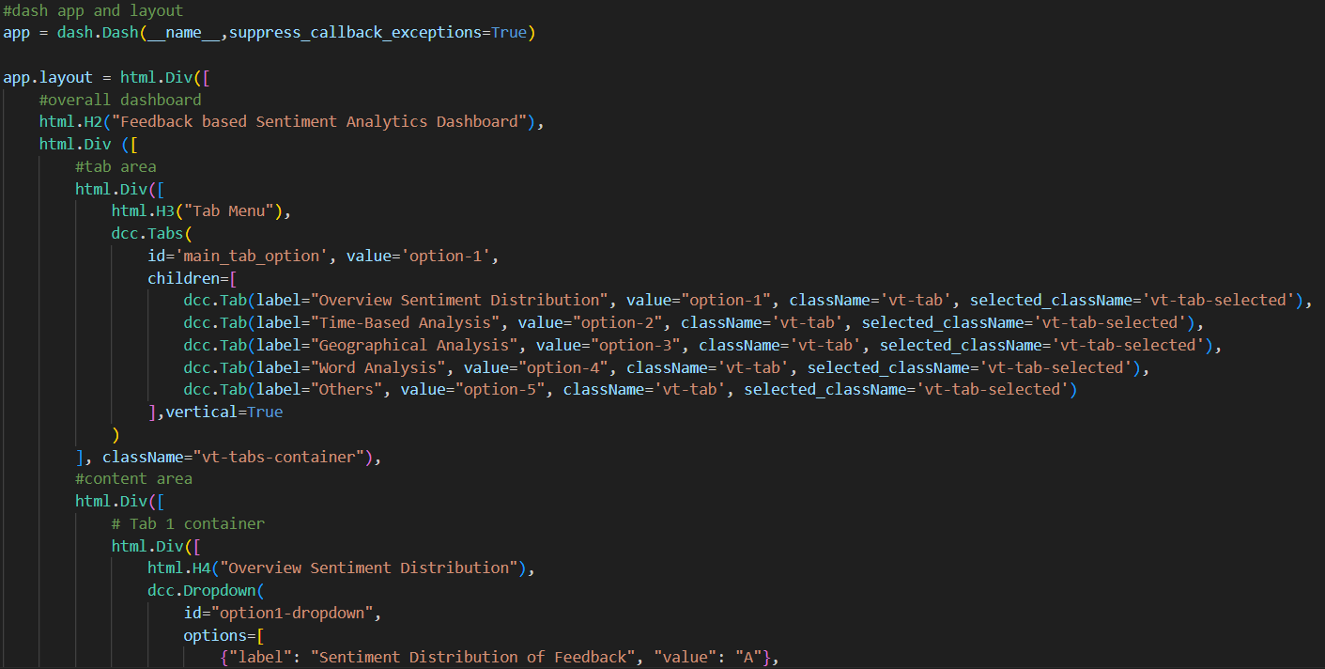

The figure above shows the basic setup for the main layout for the dashboard.

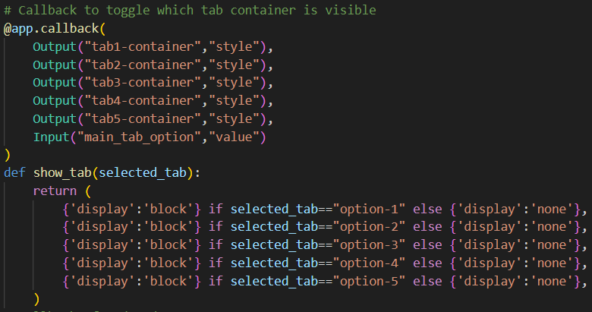

The figure above shows the display function and callback function based on the the tabs selected on the tab menu.

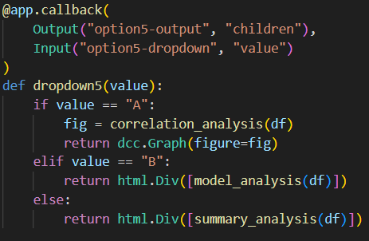

The figure above shows the display function and callback function based on the drop-down selection in one of the tabs selected.

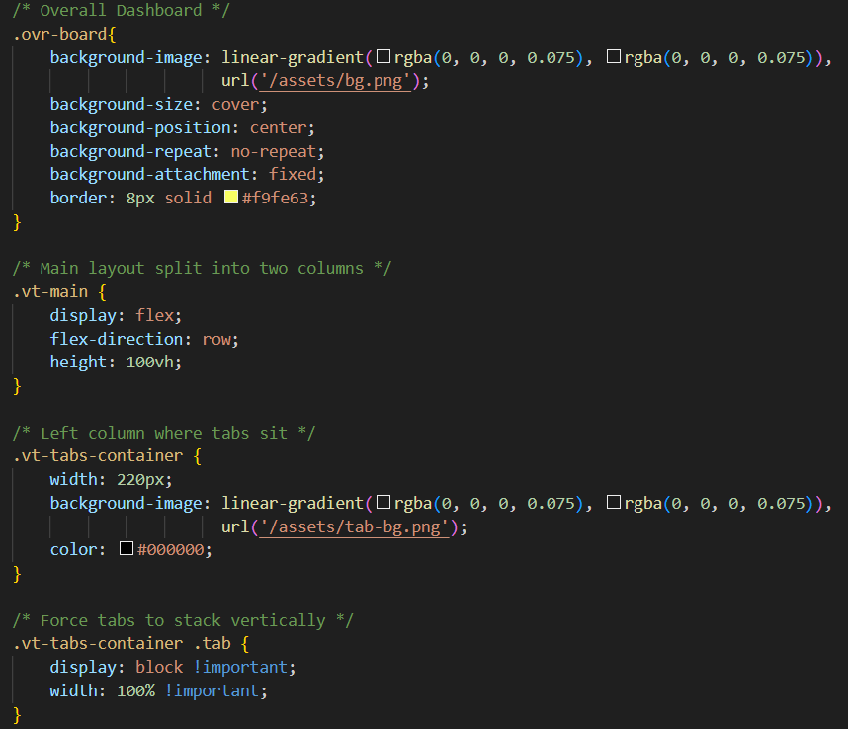

The figure above shows some of the styling for dashboard using CSS stored in assets sub directory. Dash automatically serve files from an “assets” folder by default.

**Tab 1 - Overview Sentiment Distribution**

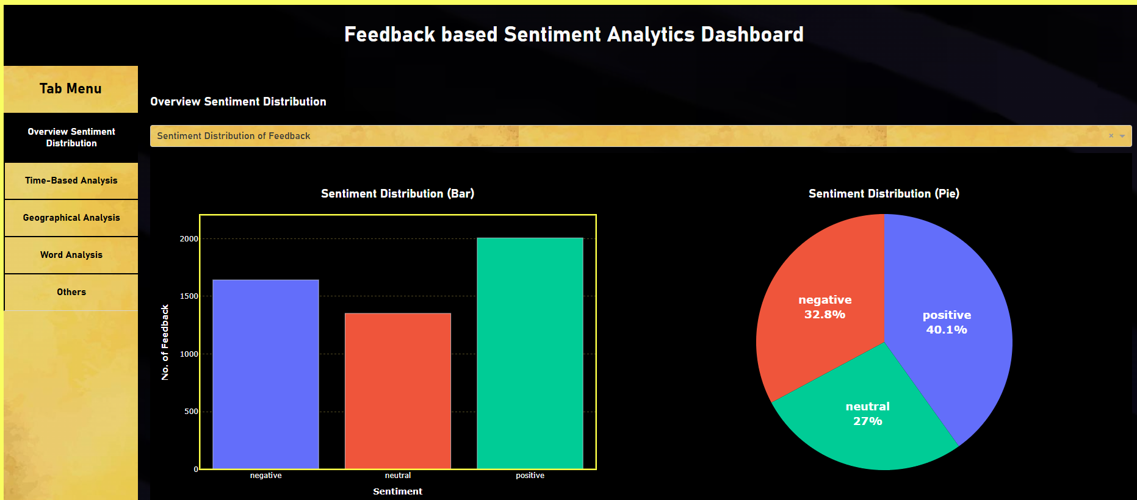

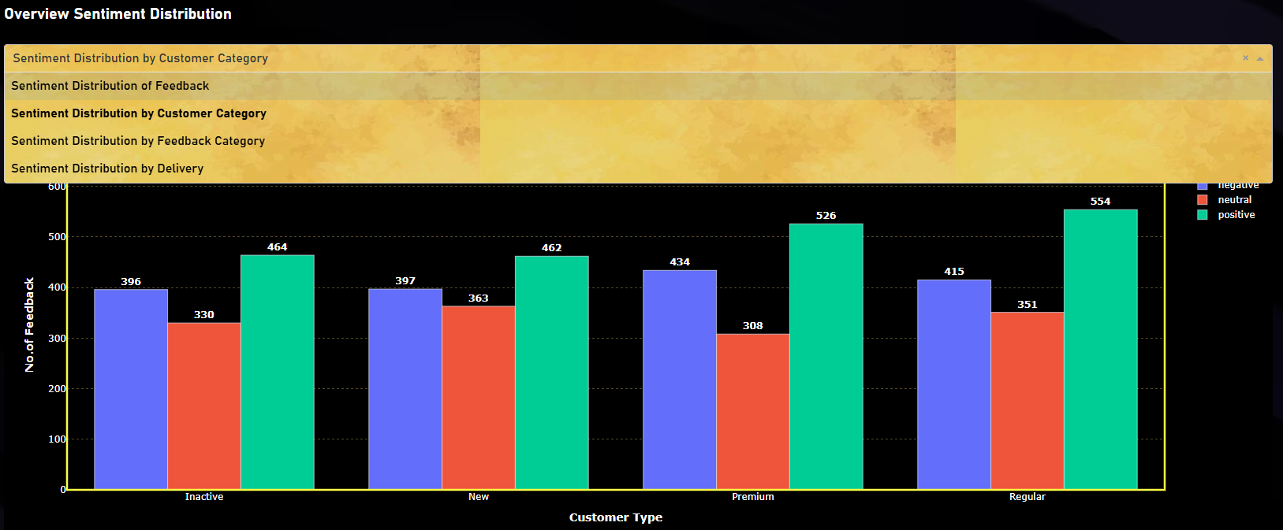

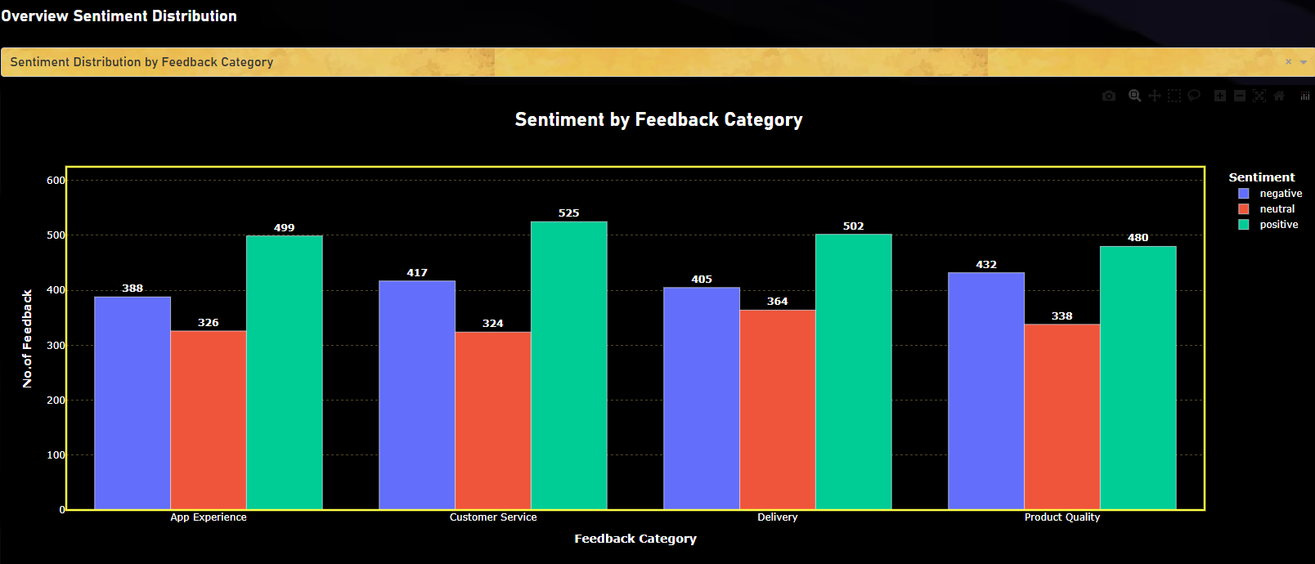

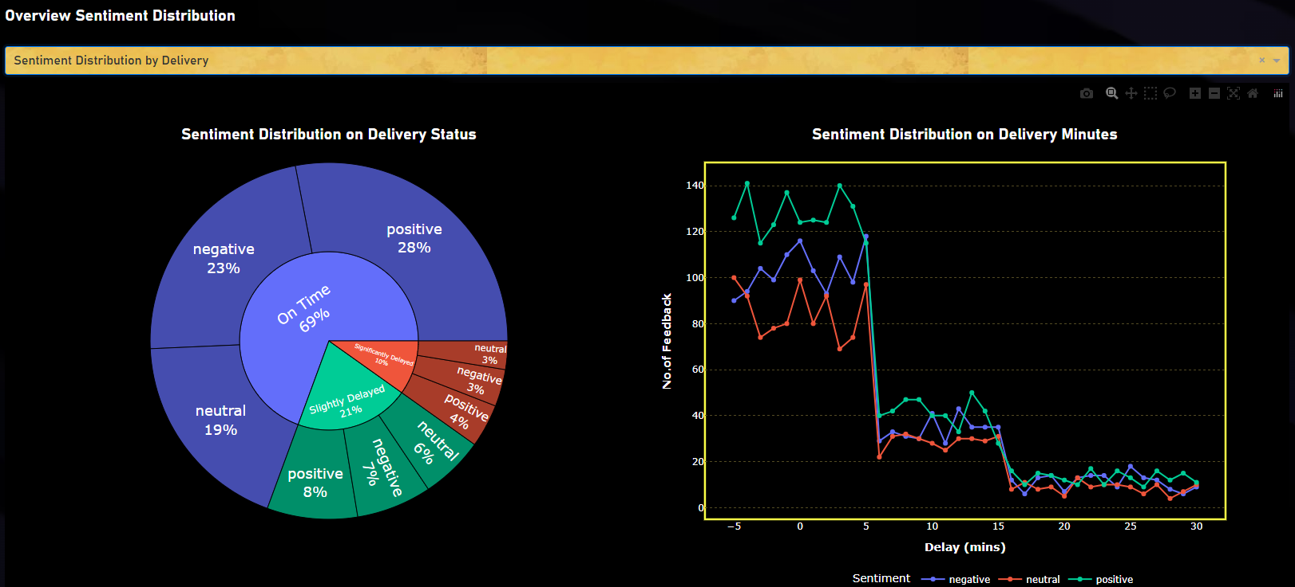

**Tab 2 - Time-based Analysis**

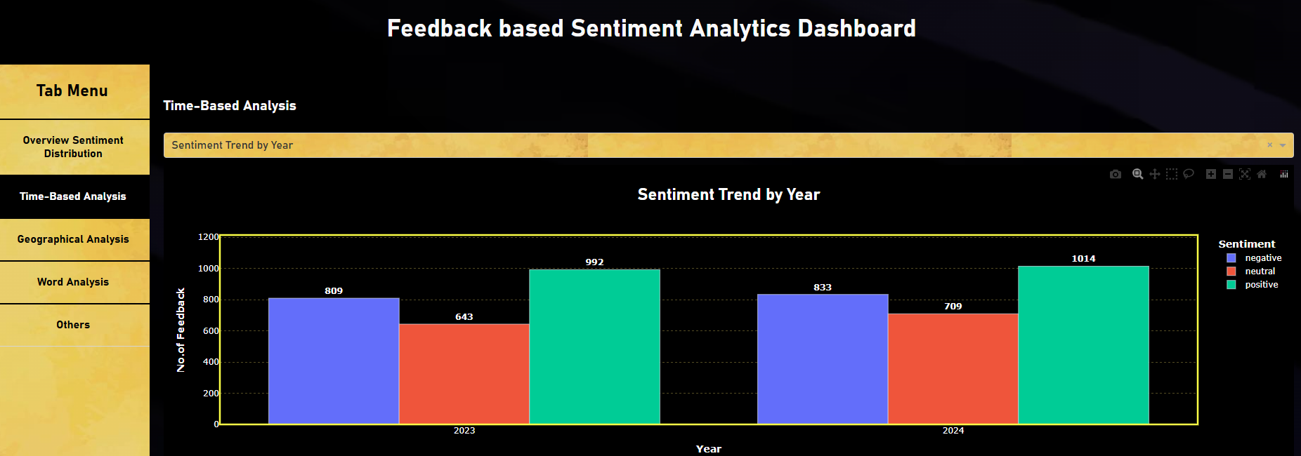

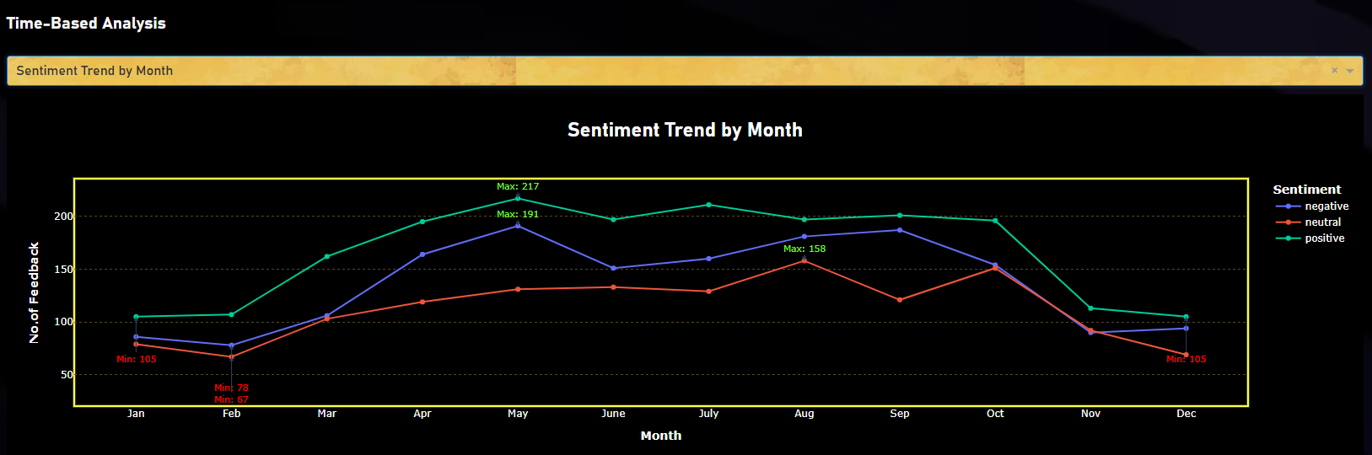

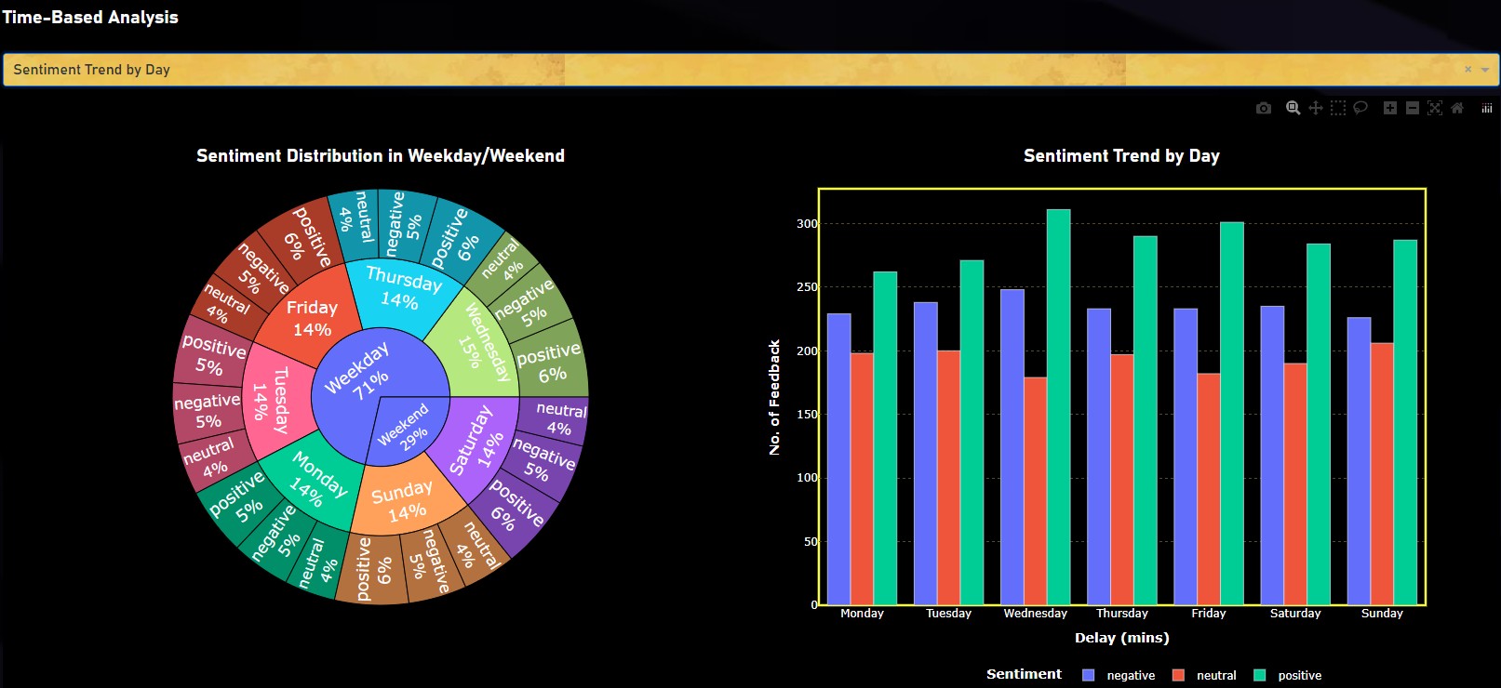

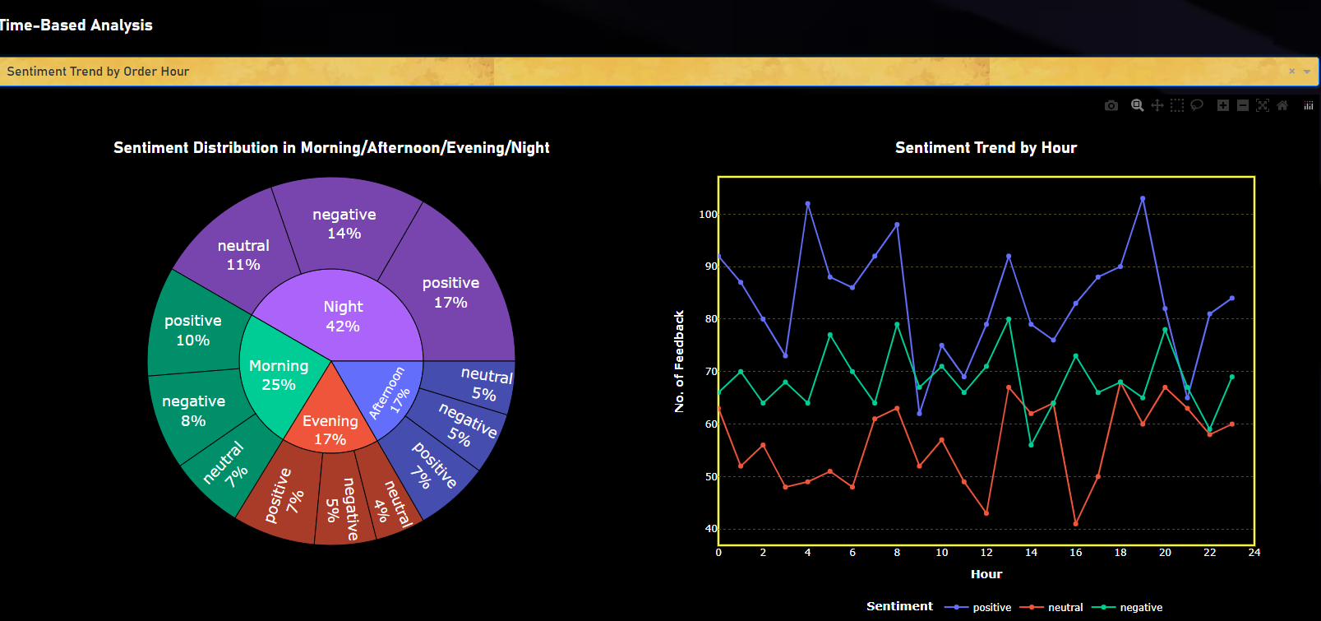

**Tab 3 - Geographical Analysis**

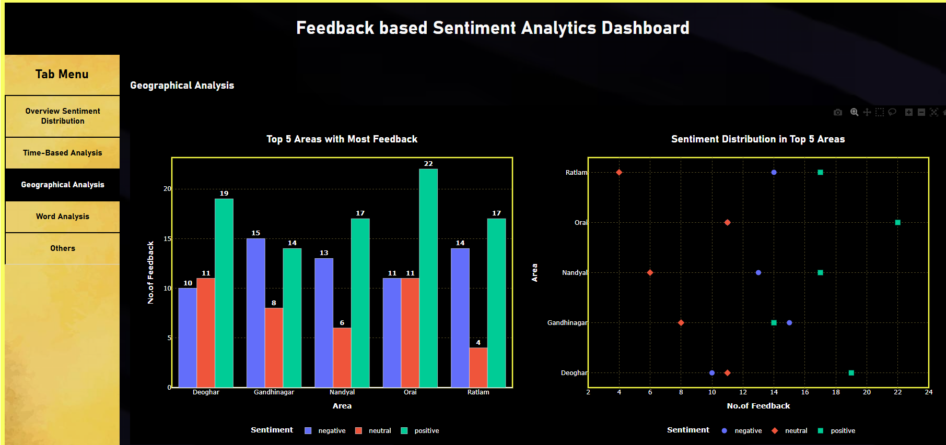

**Tab 4 - Word Analysis**

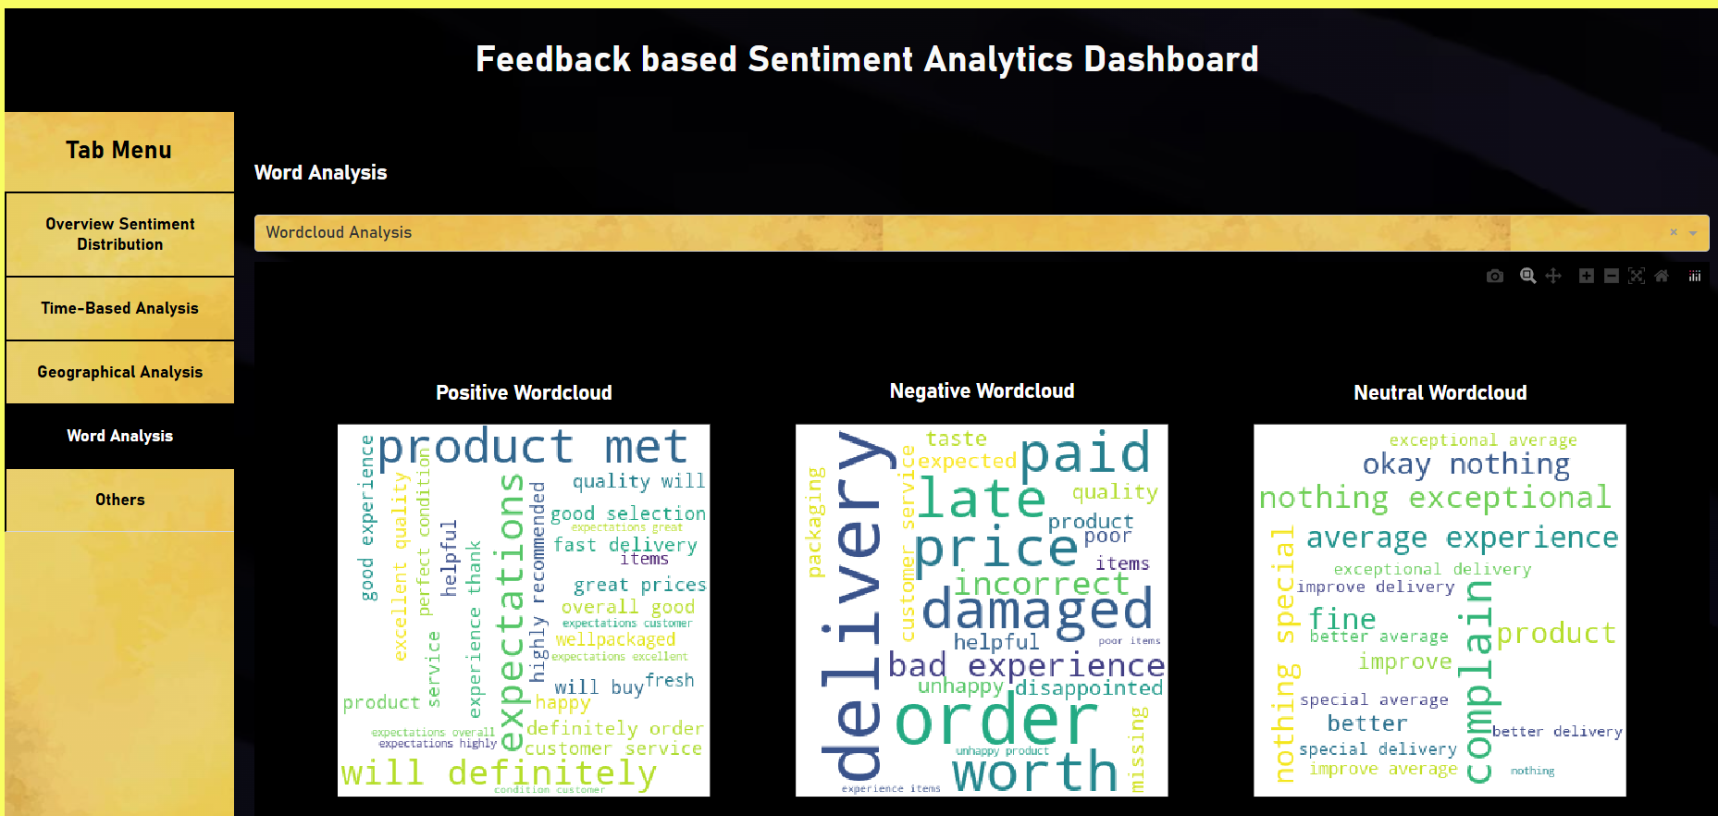

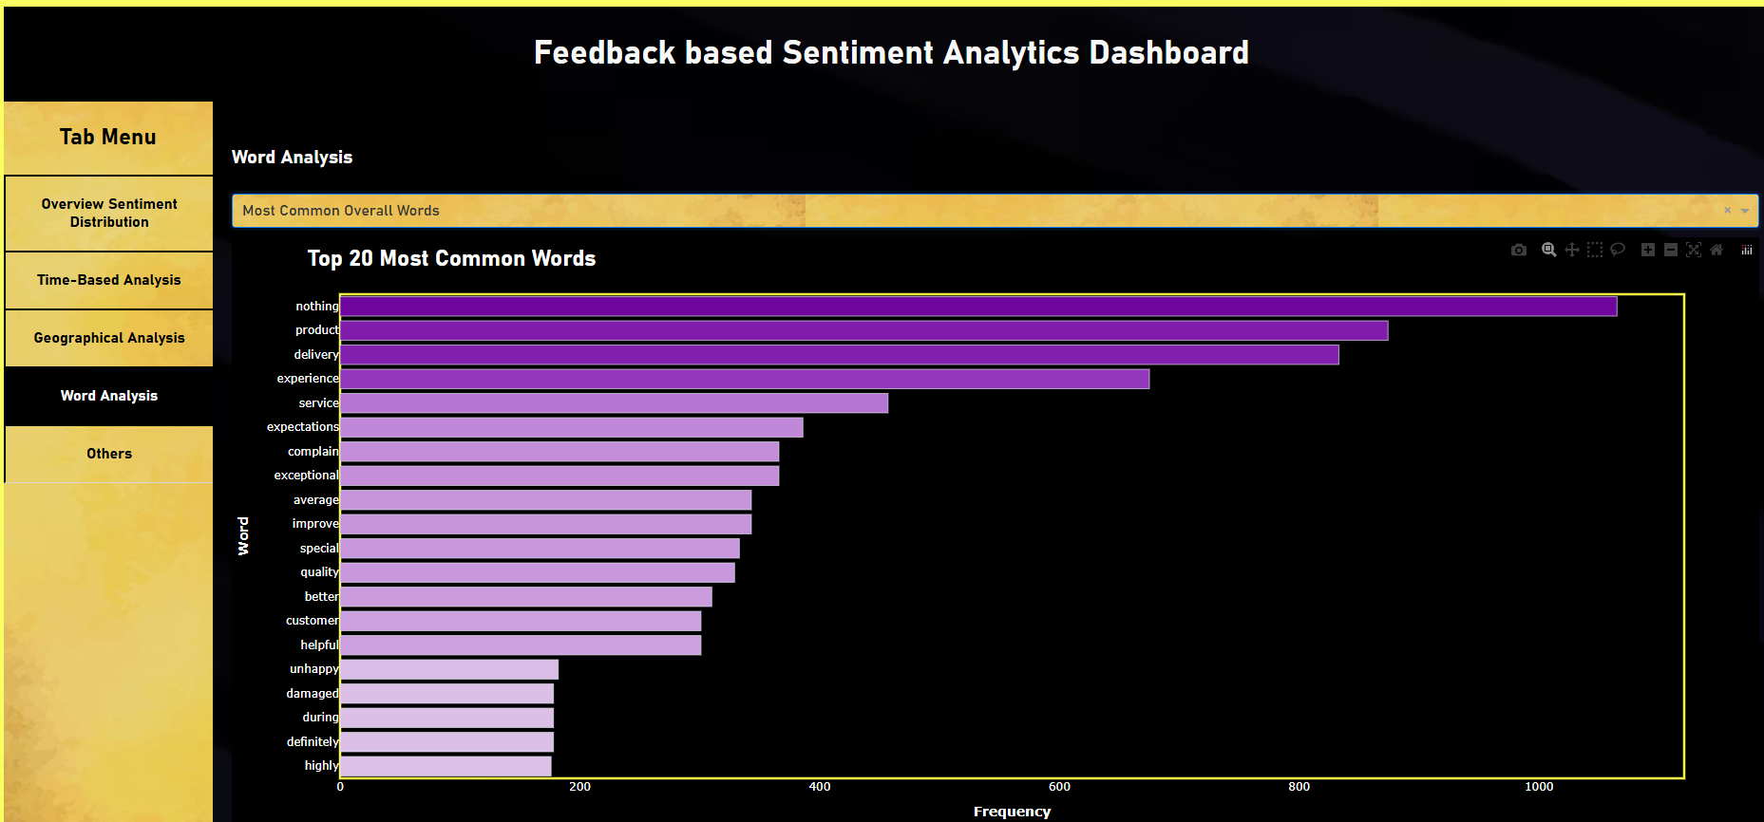

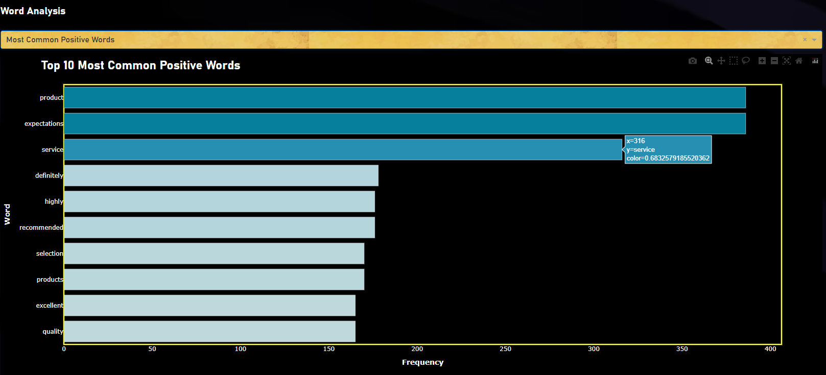

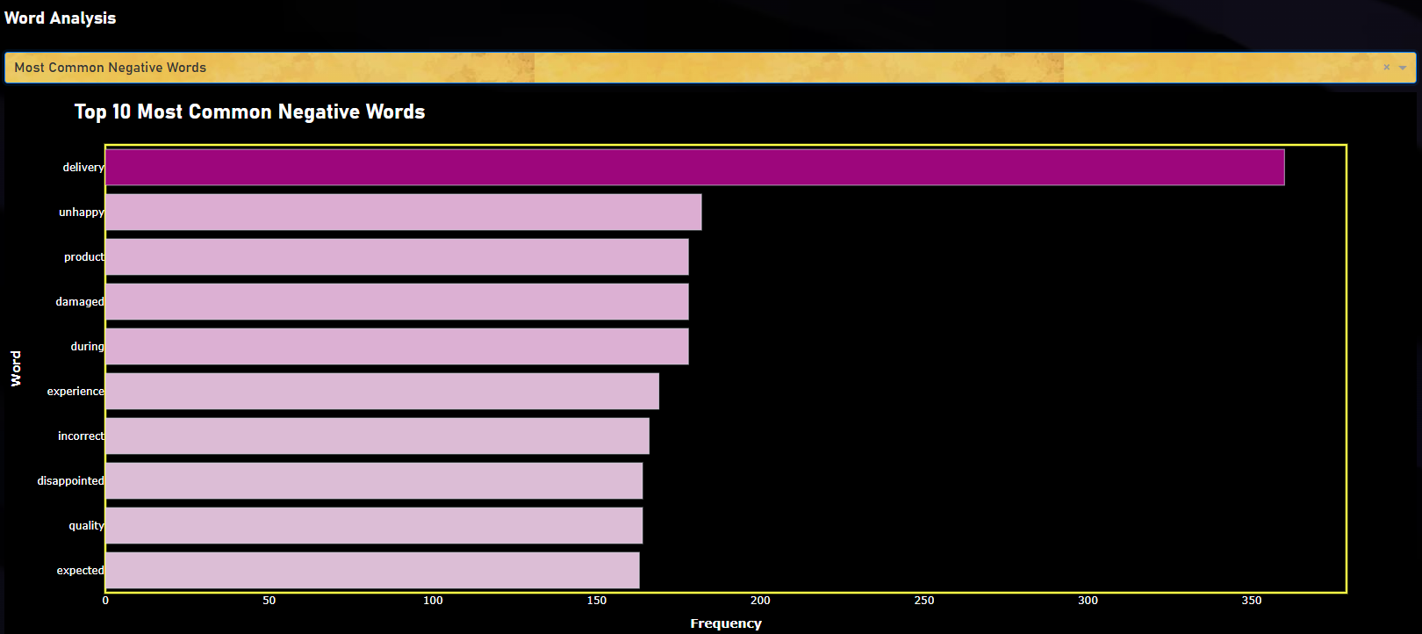

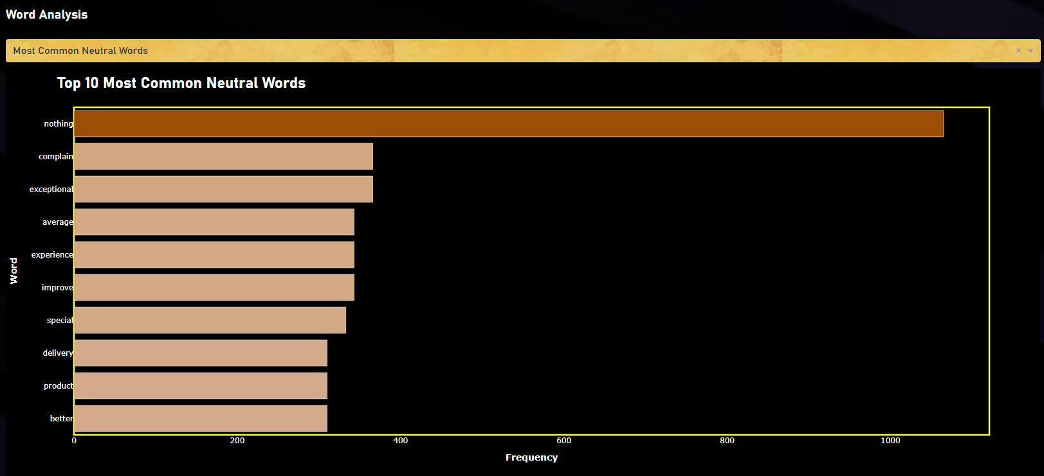

**Tab 5 - Others**

